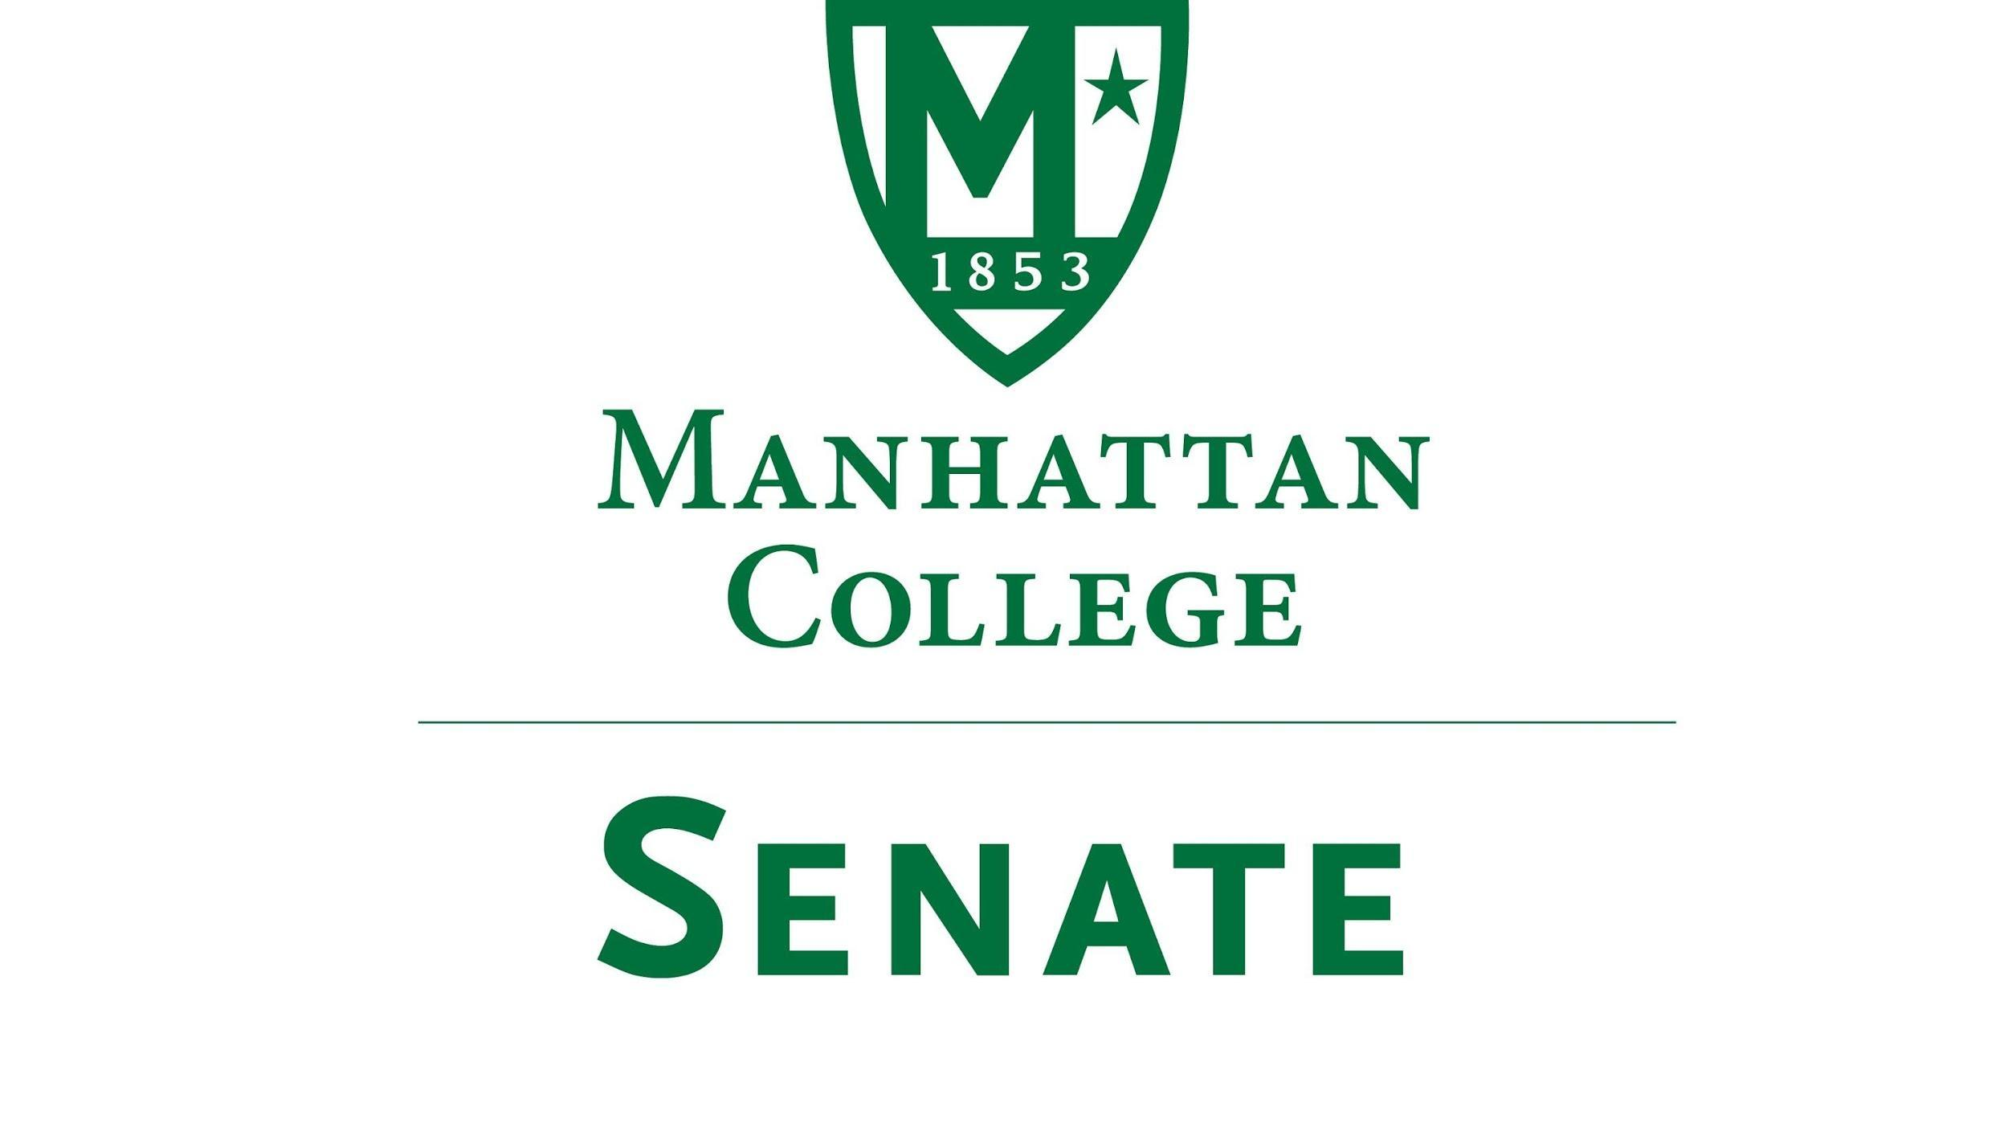

Tuesday, September 21th, 2021 | 3:30-5 pm |
Recording: https://drive.google.com/file/d/1y4kE2oASrpNxnB424jTKUNzEtCrTLX2j/view?usp=sharing
Minutes
- Roll Call
  - Present: Speaker Amy Handfield, First Deputy Speaker Tim Ward, Second Deputy Speaker Lina Baroudi, Secretary Nicole Rodi, Senator Sonny Ago, Senator Esmilda Abreu, Senator Steven Schreiner, Senator Karen Nicholson, Senator Min Jung Kim, Senator Enrico Forti, Senator William Merriman, Senator Trace Lahey, Senator Swaminathan Krishnan, Senator Maeve Adams, Senator Michael Quinn, Senator Richard Gustavson, Senator Sarah Wacker, Senator Syrita Newman, Senator Kevin Nipal, Senator James Washington, Senator Juliette Rodrigues, Senator Marin Bultena.
  - Absent: Senator Michael McEneney, Senator Pat Brady, Senator Matthew Carrigy, Senator Emma Piazza, Senator Isabel Frazza.
- Approval of the Agenda
  - The agenda was approved by a quorum
- Election of Senate Secretary
  - Secretary
    - Senator Nicole Rodi nominated herself
      - There was a second called
    - Senator Rodi was unopposed
    - Secretary-Elect Rodi’s term began immediately as of September 21st, 2021
- Approval of Previous Minutes
  - The minutes were approved by a quorum
- Reading from the “Green Book”
  - “We build too many walls and not enough bridges.” Sir Isaac Newton
- Speaker’s Report
  - Speaker Handfield thanked everyone who signed up for Senate Rep Committee work (Board of Trustees, EAC, CLC)
  - Speaker Handfield thanked Senator Nipal and Senator Rodi for checking green passes at door
  - Speaker Handfield thanked Matt and Zingy from ITS who helped test the equipment
  - Speaker Handfield thanked Thomas Riley and Edward Gomez
- Reports from the Standing Committees:
  - Educational Affairs Committee (EAC): Senator Schreiner
    - i. Senator Schreiner spoke on items discussed at the first meeting held on September 7th:
      - Report of the College Technology Committee: Pilot program in place to give the entire Manhattan community more access to complex software via Chrome box in RLC. This would allow anyone to access this software virtually anywhere.
      - Report of the Graduate Council: A new ‘virtual mode’ is being tested with 8 to 10 classes to allow for more online and distant learning opportunities for graduate students. Stay tuned for the results of that. In addition, the structure of the graduate program will change to increase the size and meet the demands and interests of current students.
      - Public Expression Policy Draft: Was given to the EAC last spring however questions regarding how this should be steered in governance arose and it was passed to Speaker Handfield. It could be passed back to EAC.
  - Campus Life Committee (CLC): Senator Ago
    - i. Senator Ago spoke on items discussed at the first meeting held on September 17th, 2021
      - The bridges leading to Horan and Lee resident halls have been closed for some time. CLC wants to work with public safety and the residence life office to concur if those entrances will be closed permanently as well as look at different staffing models to help in the possible reopening’s.
      - Students are concerned that the library is no longer open 24 hours due to budget cuts. The suggestion is to put together a petition to see how many students really feel as though it should be open 24 hours and then discuss the results with Dr. William Walter. The hope is that students are interested in this subject.
      - Growing student concerns regarding food service during student meeting due to the fact that some students may enter rooms but may not be permitted to eat. Student Engagement will release an executive order soon regarding the rules and regulations of this concern.
      - Many student organizations and offices have partnered with the fitness center to create more outdoor activities. This is following the executive order than non-vaccinated people cannot use the fitness center.
      - Ongoing concerns surrounding parking in the lot behind the student commons. It was brought to attention that Aramark employees begin filling the lot around 7am preventing students and facility from finding space there. Senator Ago will connect with public safety and Aramark to come to an agreement regarding this issue.
      - Café 1853 has been closed indefinitely for retail however the shortage in student programming space on campus has led many students to suggest using that space to host student programs. The CLC will be in contact with the events management office to discuss the possibility of renting that space for programs and events.
      - The Commuter Services and Outreach Office has begun an initiative to begin a laptop loaner service for commuter students. Many commuter students have expressed concern over not being able to complete work outside of campus due to technological obstacles. At this time the initiative is looking for donations.

- Old Business
  - None
- New Business
  - Remarks from President O’Donnell, Provost Schreiner, and Matthew McMannes
    - President O’Donnell thanked the senate for the invitation to speak and the ability to make himself available to the community for an update. He made note that his time is meant to allow for discussion rather than just a report.
i. Highlights from President O’Donnell’s Memo
1. Covid
President O’Donnell thanked those who have worked hard to create a safe campus led by the One Manhattan effort which has awarded us the opportunity to be back. He notes how amazing it has been to see the campus vibrant again after the difficulties of the past year.
Virtually 100% compliance in vaccinations among employees. Approaching 97% compliance in vaccinations among students.
Until late August there was a concern of whether or not a successful return would be possible. It took creative efforts and a push for vaccinations to make sure the college reached compliance for mandates.
Although things are looking up, we are of course still wearing masks and must remain vigilant. Continue following the rubric led by One Manhattan to keep infections rates low.
2. Finances
Uncertain position regarding revenue. The college must wait for the census which will reveal the official list of how many students are attending classes and the number of students in the residence’s hall. This information provides the exact number for revenue of the year.
“Pluses and Minuses time”: Finance team is constantly monitoring the situation. There are always savings to find on the expense side and there are always adjustments to be made on the revenue side.
Major revenue component is the undergraduate population. As of Monday September 20^{th,} we are at 753 new freshman students and 106 transfer students. The budget number for those are 750 and 125 respectfully. Therefore, 16 students light coming in on the incoming class.
Retention rate of students from freshman year to sophomore year decreased (about 60 students less than anticipated).
About 100 students more in residence than expected in the budget. Still looking closely at revenue and expense margin. Many people are still working to bring budget into balance.
3. Concerns regarding recent storms and finances
Unfortunately, there were significant damages and costs involved the mediation of the floods. Insurance covered the great majority of those costs.
4. Main message of the President’s memo regarding the finances of the college
The college recognizes that the budget can not be cut anymore. Pivoting towards investment that can lead to a pattern of growth and increased revenue.
5. Concerns regarding the restoration of salary cuts and contributions to the retirement fund
This remains a top priority in all of the college’s planning. The college continues hopes to make a substantial contribution towards the eventual full restoration of benefits and salaries as fast as possible. The college recognizes that this is important for current hardworking employees.
6. Self-directive work teams and self-manage work teams
These are problem solving groups that are meant to be small and agile. They look at specific ways to make this pivot team more efficient, effective and able to invest in the growth of this institution by:
          - Diversifying revenue
          - Being smarter in the alignment of programs for undergraduates
          - Being smarter in retention
          - Creating a financial aid model that is both efficient and powerful
There are 10 groups in which every part of the college is involved in some way. The goal is to analyze problems and create solutions for the operations of the college. This requires a certain level of expertise from those who work directly on the ground, therefore these groups will be consulting widely.
ii. President O’Donnell invited the Provost and Matthew McMannes to add to his report
1. Matthew McMannes stated that work is being conducted on the roof and interior of Alumni hall to seal up any damage and prevent further water infiltration problems. This will hopefully be concluded by this fall. Additionally, work is also being done in Leo.
iii. President O’Donnell opened the floor to questions and concerns
1. Senator Adams asked: Will the membership of the working groups be shared, and will there be faculty representation?
Yes, some of the working groups have already been running and have produced results while others are still being staffed and charged. The teams will be a matter of public knowledge to all and people will be invited to engage with them throughout the process.
Senator Schreiner noted that the Governance working group is currently forming. They will be running shorty and are finding a time and a place where everyone can meet.
Task 1: To send a message to all constituents about who and what the group is, how they are selected and what the job is. This is important because this is more than just a representative group. It is a shared governance for the community; therefore, it takes a critical look at the community (what is done well and where reparations might be made)
Senator Schreiner noted that a very broad discussion about all of this will be coming
2. Senator Adams asked: Who was responsible for selecting members of these groups and what was the process?
Speaker Handfield, Professor Groarke and Bruce Libby (Middle States) where asked for recommendations specifically for the formation of the shared governance group. Their goal was to enlist members of the community who hold a big picture for the college and could therefore translate that to shared Governance. The other groups were formed through brainstorming done my presidents and directors. They shared the problems and asked “who would be helpful to have around the table” in regard to these issues. These groups are meant to be fluid; therefore, the idea is to share member’s names with the community. People are not members of these groups because of their title but instead because they can help in solving actual problems. When the groups are published it is the hope that they can work with other organizations such as the CFA and the Senate to enlist more members, however, each group is meant to remain small.
3. Professor Groarke suggested consulting with the faculty exactly who will be chosen as faculty representation within these groups in the future.
Senator Schreiner stated that the goal of the first meeting is to make sure everyone understands what is going on and to tackle any of those issues right away.
4. Professor Groarke shared two concerns:
How to develop alumni relations better; (1) broader array of alum (2) broader array of events. Is there a strategy there to help revenue issues?
Is there a plan to make small investments in making sure existing buildings are kept up to par and that they are attractive to potential students?
Yes, facility improvements come up in multiple groups. Most notably is the concern regarding residence halls. Restarting the campus masterplan is a major reason why we need to make a pivot towards increasing revenue. We need to start building back in order to make those big investments. The Residence hall group is working towards this initiative. In terms of fundraising, President O’Donnell quotes from his memo stating, “Two groups are working here as well. The first is focusing on increased revenue generation through optimizing our financial aid strategies, modeling, and processes. The second will work to increase and diversify revenue from a range of sources, including grants, partnerships, summer programming, and expanded participation in targeted fundraising.” Therefore, President O’Donnell suggest communicating these concerns with those groups.
5. Senator Adams asked: What conversations are happening around the issues of student enrollment, tuition discounts, and future problems?
The relationship between number of students, student quality, and tuition discount rate is referred to as the “Iron Triangle” because you can’t push on one without the others shifting. Discussions about optimal class size occur every year in which factors such faculty-student-ration, classroom size, and vibrancy are considered into the revenue number. The discount rate with the current freshman class is unsustainable. This issue is being evaluated now. This is why there is one group specifically focused on financial aid.
6. Senator Quinn asked: Is the college strategizing a way to build a capacity to admit a robust number of transfer students to offset the possible damages caused by the decreased number of college ready freshman?
The college is below its goal for transfer students. Yes, one of the groups is working to help transfer students receive the proper credits to align without academic quality. Working with faculty is necessary in ensuring transfer student needs are met. Additionally, the energy of these groups is to diversify revenue. This relieves the pressure of revenue solely coming from undergraduate admissions and helps solve the potential issues caused by changing demographics.
7. What was the process regarding the search committee for Admissions and why were there no student and faculty representations?
President O’Donnell admitted that he and Senator Schreiner do not partake in non-academic search committees. However, they do expedite such processes
8. No decisions have been made regarding the restoration of salaries and retirement funds; however, individual circumstances are being taken into account. Opinions from the community are very beneficial in the decision making.
9. Professor Groarke asked: Why hasn’t a decision been made and when do you intend to decide?
All that has been received is the letter urging the college to begin investing back into the retirement fund. A decision has not yet been made because the college wants to make sure they are making the most beneficial decision for the community. President O’Donnell is open to thoughts and suggestions.
10. Senator Handfield suggested some ways in which senators can bring up these types of suggestions to be discussed by the Senate.
Can be discussed as “other” or can be brought up directly to either Speaker Handfield, First Deputy Speaker Ward, Second Deputy Speaker Baroudi, or Secretary Rodi to be placed on the Agenda.
b. Other?
i. Speaker Handfield explained the process of continuing this conversation through a motion
ii. President O’Donnell suggest inviting the CFO to hear this conversation to help resolve the issue.
iii. Professor Groarke asked: What is the timeline for receiving restoration and being able to discuss this issue in a timely matter?
President O’Donnell noted that the board meets on October 21st, therefore, the input on this matter should be received before then.
iv. Senator Nepal stated that the new bylaws will be ready for approval by the October 19th Senate meeting
v. President O’Donnell would like to hear mechanisms for properly getting input for this issue.
vi. Speaker Handfield noted that adjustments to the timeline can be made.
vii. Senator Krishnan suggested a descriptive document that lists the pros and cons of such decisions. This would allow the Senate to make informed decisions on the matter.
1. Vote to have a special meeting
a. All in favor
viii. Speaker Handfield will make all apparent documents accessible
- Adjourn
  - The meeting was adjourned at 5:07. A special meeting of the Senate will be announced.

