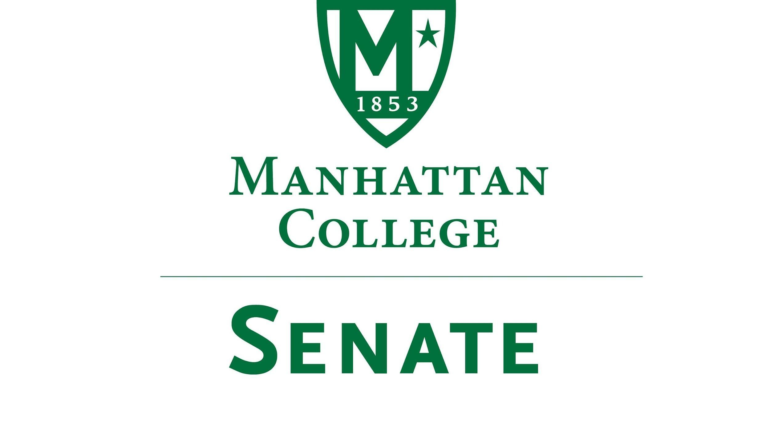

Special Meeting, October, 6th 2021 | 12-1 pm |
Recording: meet.google.com/ptu-jaef-zcu
Minutes
- Roll Call
a. Present: Speaker Amy Handfield, Secretary Nicole Rodi, Senator Sonny Ago, Senator Esmilda Abreu, Senator Min Jung Kim, Senator Enrico Forti, Senator William Merriman, Senator Trace Lahey, Senator Swaminathan Krishnan, Senator Maeve Adams, Senator Michael Quinn, Senator Richard Gustavson, Senator Sarah Wacker, Senator Syrita Newman, Senator Kevin Nipal, Senator Marin Bultena, Senator Michael McEneney
b. Absent: First Deputy Speaker Tim Ward, Second Deputy Speaker Lina Baroudi, Senator Steven Schreiner, Senator Karen Nicholson, Senator James Washington, Senator Matthew Carrigey, Senator Juliette Rodrigues, Senator Pat Brady, Senator Matthew Carrigy, Senator Emma Piazza, Senator Isabel Frazza.

- Approval of the Agenda
              - Speaker Handfield apologized for such a vague agenda. She clarified that this decision was based on the information in the bylaws and the previous discussion at the September 21st Senate meeting
              - It was brought to Speaker Handfield’s attention that the agenda should be revised before the meeting commences
                - Specifically, the point of “New Business”: Formation of a subcommittee for the creation of proposals or other documents relating to the discussion of Old Business (a)
                - Regarding the question of if a subcommittee should be made, Speaker Handfield suggested that the word “formation” be changed to “a discussion about this formation of a subcommittee”
                - Speaker Handfield asked if this change was okay with everyone. It was approved

3) Speaker’s Report

Speaker Handfield stated that for middle states reasons and for research reasons she has been looking at old minutes. She mentioned that she began sitting on Senate in 2013. Based on her experience a special meeting like this has never been called before. According to the bylaws they definitely can be. Therefore, this meeting is very special and important. We are trailblazers.

Speaker Handfield was in email correspondence with Matthew McManness (CFO) in regard to questions regarding finance and the reinstatement of benefits. He suggested that the Senate compile questions to be sent to him and to later be addressed in a meeting. For example, last year a forum was provided to field questions that were brought into later discussion.
4) Old Business
  - Continued discussion of the reinstatement of benefits for staff, administration, and faculty
                - Senator Adams asked: Why aren’t President O’Donnell and Matthew McManness present at this meeting? What is our plan of action regarding communication?
                - Speaker Handfield noted that this meeting was called to continue the discussion from the last meeting and to create a plan of action. Given the time constraints, it was difficult planning this meeting and a plan of action.
                - Shawn Ladda wanted to clarify that the Faculty Welfare Committee (FWC) recently met and suggested that restoring retirement benefits should be prioritized because the college automatically puts in money for retirement. Each individual then has the prerogative to add more money to that. The FWC strongly recommends prioritizing retirement because everyone will get money. Some people did not have their salary cut; therefore, they will not get any money back. The FWC feels that it is fairer to prioritize retirement now with the money available and then later create a plan to fully reinstate both retirement and salary
                - Senator Wacker stated that she was concerned about the quote forwarded from Mr. McManness. It seems strange that in leu of them not yet receiving our feedback, he is choosing to prioritize an option that was the opposite of what the FWC has already recommended. In other words, the opposite of what the faculty has already communicated to him.
                - Shawn Ladda followed up by saying that FWC is concerned about the entire community and the only way to ensure that everyone is accommodated is to restore retirement benefits first.
                - As a member of FWC, Margaret Groarke also stated that any dollar put towards salary reimbursement will be taxed whereas the money put towards retirement remains tax free. This creates a greater advantage for the amount of dollars available to all faculty, staff, and administration.
                - Senator Quinn asked who Matthew McManness was referring to in his statement.
                - Speaker Handfield agreed that this was vain. The benefits should be the topic of discussion. She assumed that the CFO was referring to the staff as those who do not contribute to retirement.
                - Shawn Ladda clarified that some people choose not to match the money the college already puts into retirement.
                - Senator Adams recommended making a decision. It seems that the administration persists in misunderstanding the concept of co-governance as communication. Co-governance is not the cycle of sending information and responding with questions. Senate should decide how we plan to respond (in a statement or in the form of question) as well as register our concern of sending this statement or question around the term co-governance. We need to continue reiterating this. Why do they continue to ask us to do more work without getting meaningful responses back?
                - Speaker Handfield added that the Senate has been asked to submit questions multiple times, therefore creating another way of getting actual information is open to discussion
                - Senator Nipal asked if the Senate can summon Matthew McManness to the next Senate meeting. It seems that there is a lack of communication and concern from the staff regarding benefits being cut. Senator Nipal has many questions that need clarification from him before they can be posed.
                - Speaker Handfield agreed that summoning Matthew McManness would be an excellent idea.
                - Senator Merriman stated that we need to know how much funds are available to be devoted to either salary reinstitution or pension reinstitution. It seemed that with knowing the amount, we would know what could be done. The census would help us to make this decision. Does the FWC have an idea of what these funds look like?
                - Shawn Ladda agreed that the amount of money is needed. However, even with a million dollars going towards retirement reimbursement, everyone will make more money because of interest and tax implications. This is why FWC has stated to the president and CFO that retirement should be the priority.
                - Senator Krishnan asked: Is there a benefit to the college if they choose to allocate the funds to either retirement or salary?
                - Senator Quinn stated that it is great branding for the college to say, “We restored salaries!” rather than to say, “We restored a little bit of retirement”. It interesting to know how much this plays a part based on the non-convincing excuse given by the administration.
                - Speaker Handfield asked the Senate how should we move forward with this? It sees that a document would be most favorable
                - Senator Wacker moved that the Senate stand behind the FWC in their proposal that was already made to the administration. This would require less work from the Senate, and she believes their plan is very sound.
                - Senator Adams seconded that with the addition that this decision be written and distributed among constituents. Formally back the FWC.
                - Senator Nipal agreed that the staff council will back this decision.
                - Senator Wacker moved to create a resolution to then be voted on and distributed among constituents.
                - Senator Gustavson seconded motion
                - Shawn Ladda stated the FWC’s statement: “Faculty Welfare Committee strongly advocates for the priority of reinstatement of benefits. First, it would have far more long-term effect. Second, many members of the community make under $75,000 so the restoration of salaries only affects those who are relatively better paid, while everyone gets these benefits.”
                - Speaker Handfield stated that the Senate can create a similar statement.
                - Senator Forti suggested that within this document, the Senate request the ambiguous numerical data of the cost position of the college. This will would help to understand the tradeoffs of either decision made.
                - Senator Quinn backed this statement by Senator Forti, “numerical data describing the cost structure of the College and the evolution of revenue and costs over the last 5 years.”. Additionally, he noted that the Senate was supposed to have already received this information. Because we did not, the document should state that this hindered our ability to make a fully informed decision.
                - Senator Gustavason asked for clarification on our voting of the resolution and the official document.
                - We will vote to approve motion
                - Regardless of what is available, FWC is stating that the priority is retirement. It might be better not to muck the waters.
                - Senator Adams endorses Shawn Ladda. Additionally, we don’t want to lessen the force of this recommendation. Instead, express concern and resolve to support FWC. They should not be causal.
5) New Business
a) Formation of a subcommittee for the creation of proposals or other documents relating to the discussion of Old Business (a)
  - Other?
Resolution in the form of an official document by the Senate supporting the FWC’s proposal
              - The official statement is: The Senate endorses the FWC position: "Faculty Welfare Committee strongly advocates for the priority of reinstatement of benefits. First, it would have far more long-term effect. Second, many members of the community make under $75,000 so the restoration of salaries only affects those who are relatively better paid, while everyone gets these benefits."
              - Speaker Handfield asked who should this be addressed to and how?
              - Senator Merriman asked how this will be given to administration
Senator Handfield will create a shared document to be sent to President O’Donnell ASAP
              - Senator McEneney asked for a vote on the language of the document
              - Majority vote was reached in the google meet chat

6) Adjourn
a) The meeting was adjourned at 12:44 pm. The next Senate meeting will be on October 16, 2021

