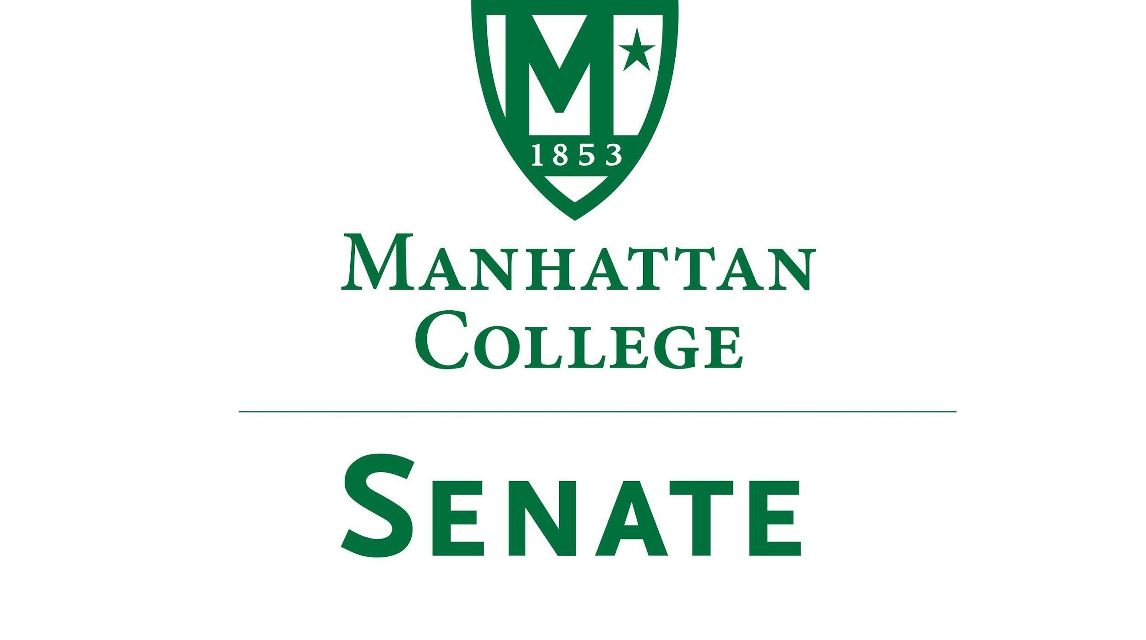

Tuesday, November 16th, 2021 | 3:30-5 pm |
Google Meet: meet.google.com/ufp-gwmf-eqf
Livestream: stream.meet.google.com/stream/227bdf69-7576-4948-9760-4ff1f3c637c0

Agenda
- Roll Call
- Approval of the Agenda
- Approval of Previous Minutes
- Reading from the “Green Book”
- Speaker’s Report
- Reports from the Standing Committees:
  - Educational Affairs Committee (EAC): Senator Schreiner
  - Campus Life Committee (CLC): Senator Ago
- Old Business
- New Business
  - Student Work Study Presentation: Rabea Ali, Assistant Director of Work Study & Tap Certifying Officer, Financial Aid, and Denise Scalazo, Director/Financial Aid Administration
  - Discussion regarding classes protocol for inclement weather closings and delays: Anirban De, Civil & Environmental Engineering
  - Other?
- Adjourn

