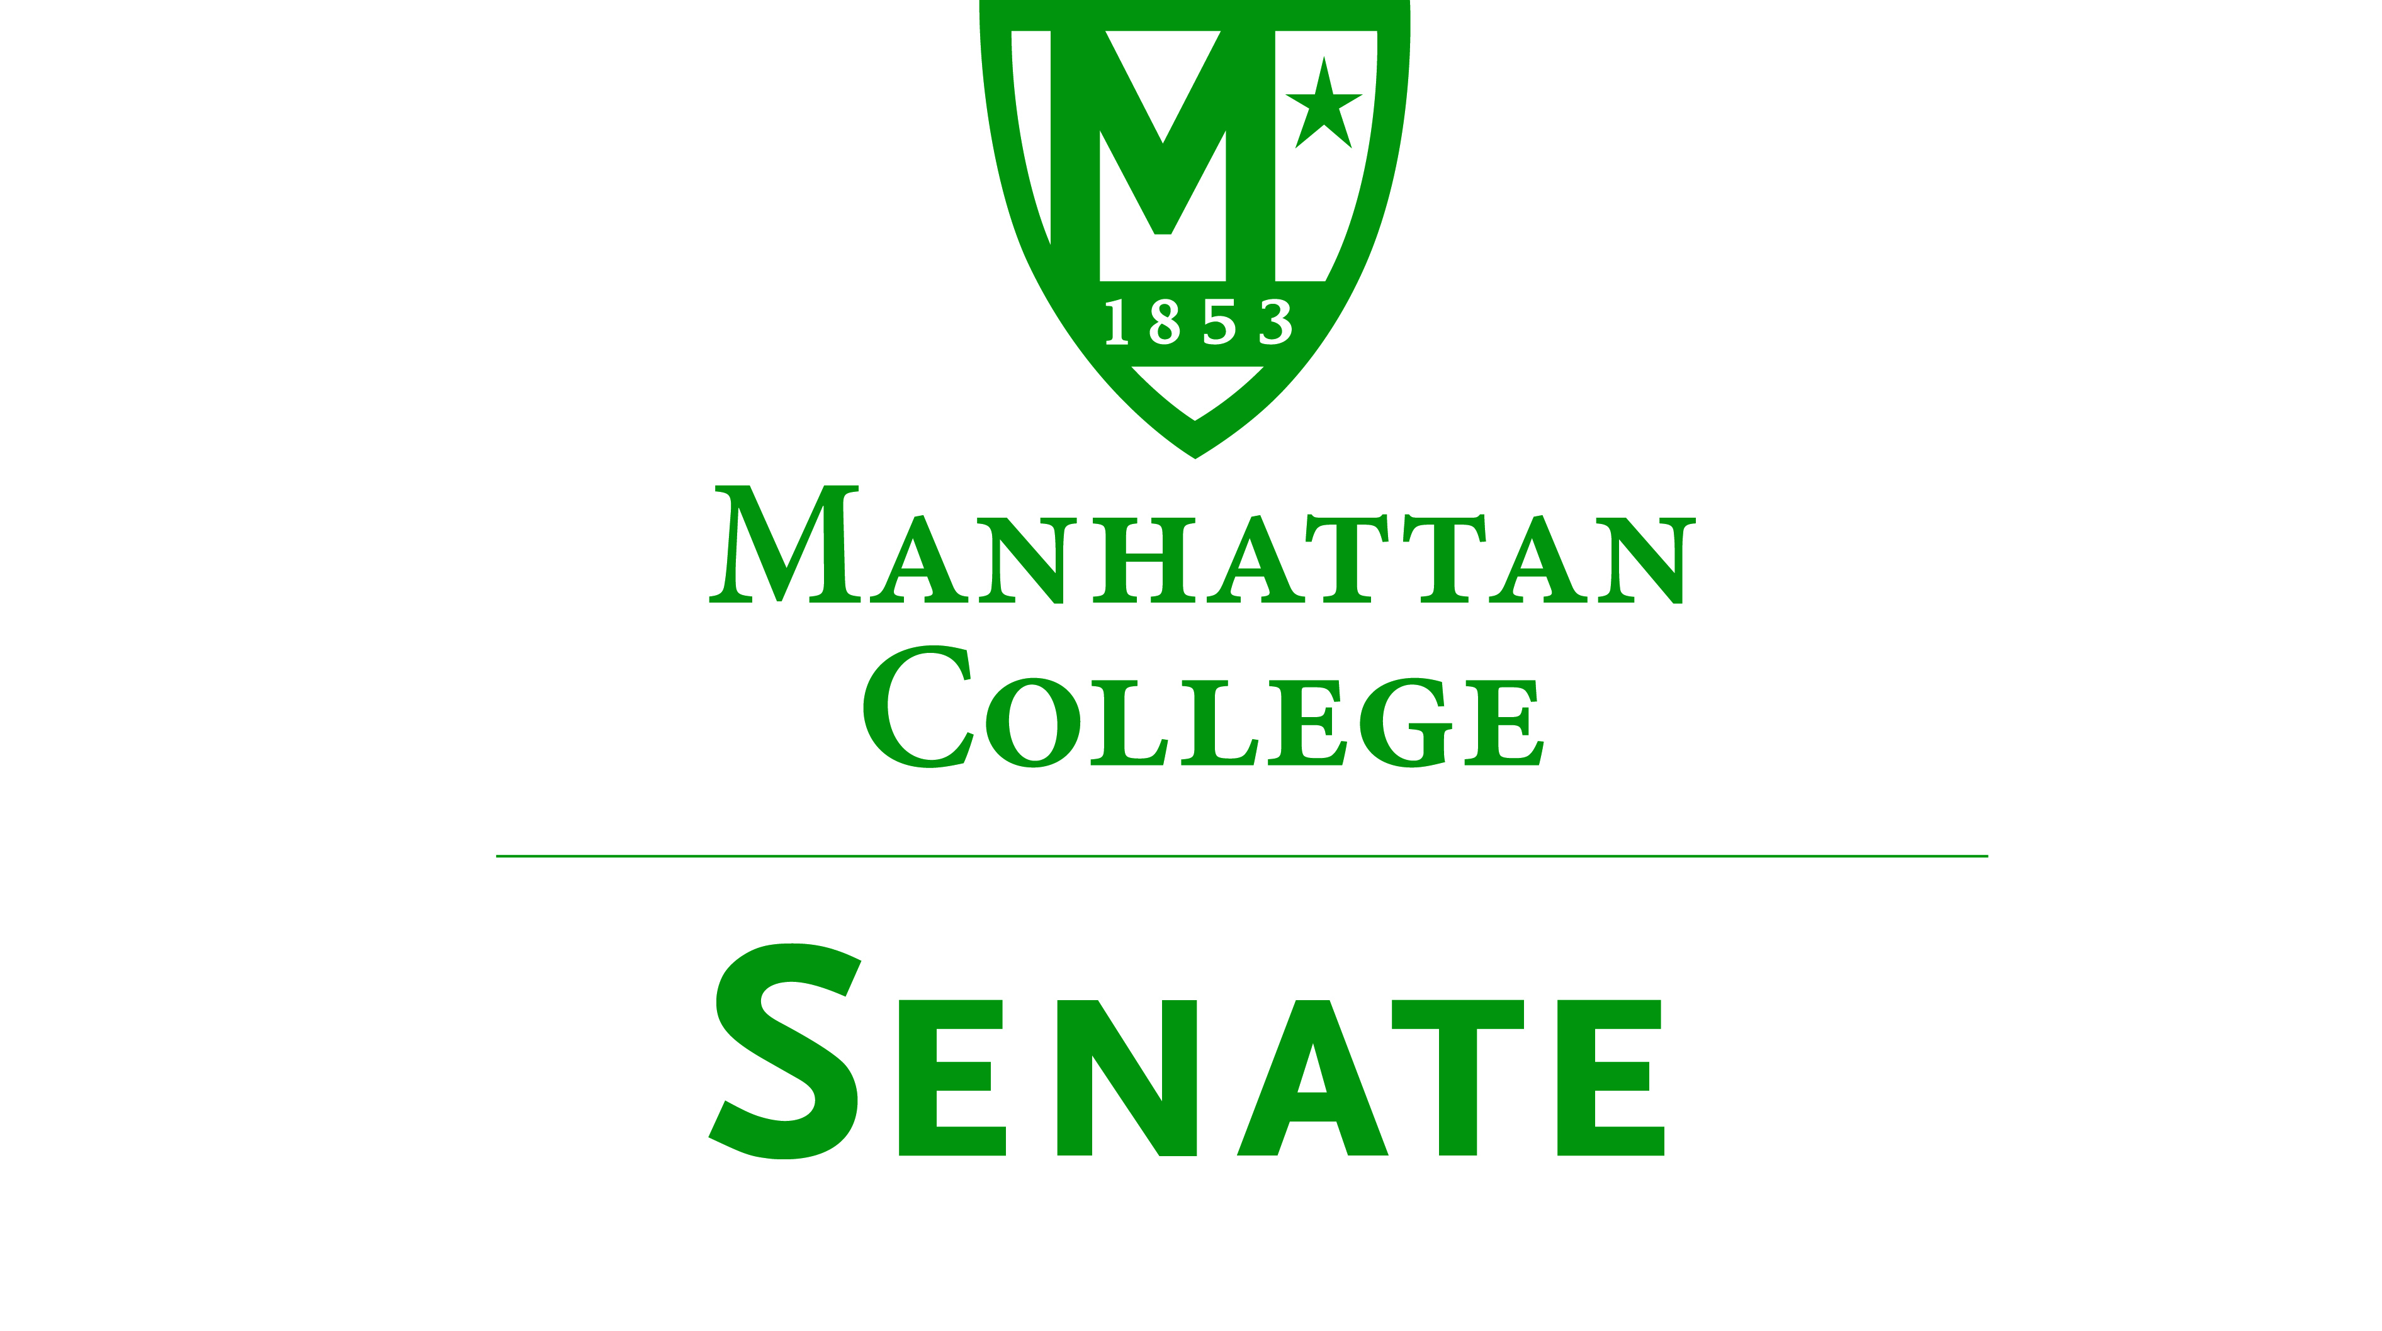
Tuesday, September 16, 2014 | 3:30pm | Alumni Room, O’Malley Library

Minutes
In Attendance: Amy Handfield, Andrew Greene, Constantine Theodosiou, Giancarlo Schillaci, Goli Nossoni, Jawanza Clark, John Leylegian, Kevin Hill, Kimberly Hickey, Kudret Topyan, Kyle Karp, Matthew Jura, Michael McEneney, Ming Hsu, Monica Horan, Patricia Sheridan, Patrick McCann, Paul Droubie, Peter McCarthy, Sonny Ago, Syrita Newman, William Casey, William Clyde, William Merriman.
Absent: Alex Shalian, John Tudisco, Margaret McKiernan (excused), Richard Saterlee.
- Roll was taken. Quorum was met. Meeting called to order by Speaker Droubie.
- The Agenda for the September 16, 2014 meeting of the Senate was approved.
- The Minutes of the May 17, 2014 meeting of the Senate were approved.
- Speaker Droubie read an excerpt from p. 78 of the “Green Book.”
- President’s Report: President O’Donnell
  - President O’Donnell plans to visit the Senate on a regular basis.
  - The President’s Fall Convocation Remarks can be found on the Leadership and Governance area of the MC website: http://manhattan.edu/about/leadership-governance/presidents-speeches-addresses
  - This year we have about 918 new students.
    - About 750 of these are new first-year students, and about 168 are transfers
    - The incoming class is more geographically and ethnically diverse.
    - MC is now an associate member of the Hispanic Association of Colleges and Universities (HACU).
  - Residence halls are 98% full.
  - There are currently about 3250 total undergraduate students---ideally this would be 3400. The college’s goal is to recruit about 800 new students per year.
  - The new commons building has exceeded (high) expectations. There will be a formal dedication of the new building (and the building will officially open) on October 15.
  - On Thursday, September 18, East Hill will be renamed to Lee Hall, after Margaret Lee O’Malley.
  - Facilities Master Plan will be discussed this year.
    - There will be a Town Meeting to discuss the new Master Plan on September 30.
    - The Master Plan will integrate into the Strategic Plan.
    - Phase I of the Strategic Plan is just ending.
      - There will be forums and task forces to revisit and discuss the progress of the Strategic Plan.
      - What will the new capital campaign be for?
      - Senator Greene asked what the desired student to faculty ratio is
      - Senator Clyde replied that the same ratio (12:1 or 16:1, depending on how it is calculated) is assumed.
      - The timeline and process for the revision and refocusing of the Strategic Plan will be mapped out at the October Board of Trustees meeting.
      - Goal: Fully approve a plan for the June 2015 Board meeting.
  - The Commons campaign has raised $42.2 million (dedicated).
  - The endowment for the college stands at about $80 million.
- Speaker’s Report: Speaker Paul Droubie
  - Discussion of potential agenda items and meeting topics for the academic year
    - The Agenda Committee would like to have the Senate involved in the discussions of the Master Plan and revision of the Strategic Plan.
    - There are changes coming through NCAA sports, such as paying players (especially in Division I).
      - The Agenda Committee would like to see a discussion about the implications of these new rule changes for Manhattan College.
      - Would like to invite Richard Saterlee to discuss the rule changes and implications.
    - VP Michael Mash to discuss finances.
  - Senators, please go back to constituents and talk about the Senate. Most meetings are open to the campus community, and the Senate welcomes guests to meetings. There are refreshments.
  - Committee Appointments
    - Campus Life Committee appointments: Kimberly Hickey, Linda-Marie Shehata, Amy Handfield.
- Reports from the Standing Committees
  - Educational Affairs Commission (EAC): Senator Clyde
    - Please see the Minutes of the EAC. In the future, the EAC Minutes will be available to Senators before the Senate meeting so a complete report does not need to be given.
    - Three committees report to the EAC: The College Curriculum Committee (CCC, faculty only), The Campus Technology Committee (CTC), The Library Committee.
    - There has been discussion about moving the location of Commencement 2015.
      - Madison Square Garden Theater will not allow a reservation until April 2015, which is too late.
      - The Westchester County Center is another option, but another survey needs to be done.
        - There would be 4+ tickets per student at WCC vs. 3 tickets per student on campus.
        - Commencement would need to be on Saturday at WCC vs. Sunday on campus.
    - The withdrawal deadline has been changed back from the 9th week of the semester to the 12th week of the semester.
    - Course and Teacher Evaluations will be going online.
      - There will be an online pilot for the Fall 2014 semester.
      - The plan is to go fully online in the Spring 2015 semester.
    - There is an ongoing discussion about digital learning (replacing some class time with online activities) at MC.
    - The Arches Program has finished its 3rd year.
      - An analysis of the program has been done, led by David Mahan and Senator Clyde. Outcomes: clarification of the program and marketing are important. There were some good outcomes, and some not good outcomes.
  - Campus Life Committee: Sonny Ago
    - The Committee has yet to meet this semester.
- Old Business
  - There was no old business.
- New Business
  - There was no new business.
  - Speaker Droubie reminded Senators to reach out to bring people to the Senate meetings.
- Adjourned at 4:38 pm.
Respectfully submitted by M. Jura.

