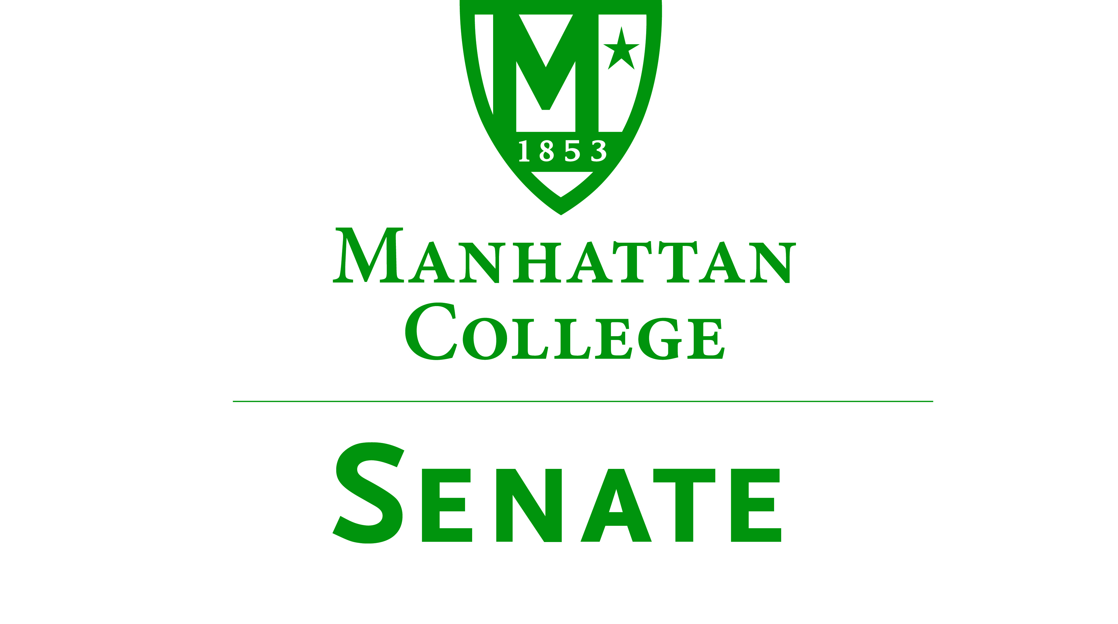
Tuesday, October 21, 2014 | 3:30pm | Alumni Room, O’Malley Library

Minutes
In Attendance: Amy Handfield, Andrew Greene, Constantine Theodosiou, Goli Nossoni, John Leylegian, Kevin Hill, Kimberly Hickey, Kudret Topyan, Margaret McKiernan, Matthew Jura, Ming Hsu, Patricia Sheridan, Paul Droubie, Richard Saterlee, Sonny Ago, Syrita Newman, William Casey, William Merriman.
Absent: Alex Shalian, Giancarlo Schillaci, Jawanza Clark (excused), John Tudisco, Kyle Karp (excused), Michael McEneney (excused), Monica Horan, Patrick McCann, Peter McCarthy (excused), William Clyde (excused).
- Roll was taken. Quorum was met. Meeting called to order by Speaker Droubie.
- The Agenda for the October 21, 2014 meeting of the Senate was approved.
- The Minutes of the September 16, 2014 meeting of the Senate were approved.
- Speaker Droubie read an excerpt from p. 46 of the “Green Book.”
- Speaker’s Report: Speaker Paul Droubie
  - There will be a sculpture exhibit in the Alumni Room tomorrow.
  - At the next Senate meeting, VP of Finance Michael Masch will give his yearly presentation on the finances of Manhattan College.
- Presentation on changes in the NCAA rules by Vice President for Student Life.
  - Dr. Richard Satterlee:
    - MC is in a Division I program in the Metro Atlantic Athletic Conference (MAAC). There are 11 schools in MAAC.
    - MC has 19 sports teams and a total of 349 athletes.
    - For the 2013-2014 AY, Loyola University is out of the conference, while Quinnipiac and Monmouth are in. Most other schools in the conference have modern arenas and modern athletic facilities. There was a conscious effort to keep all the schools in the northeast (this keeps travel costs down) with like-minded schools.
    - MC is in Division I, 3A (schools with this classification usually do not sponsor football)---it is known as the “basketball conference.” All 11 schools in the conference participate in basketball.
    - There is a goal to improve women’s sports at MC.
    - President O’Donnell sits on the MAAC Council (a governing body for the MAAC). The MAAC Council office is in NJ.
    - Leadership in our conference is to continue to have access to post-season basketball and have access to the revenue structure of the NCAA.
    - The possible changes that the 5 “power conferences” (a.k.a. the “Big 5”) make can have an impact on the ability of MC to compete.
  - Athletic Director Noah LeFevre:
    - The “Big 5” consists of ACC, Big 12, Big Ten, SEC, PAC-12.
    - These conferences want to institute their own rules (especially related to football).
    - The 67 institutions in the Big 5 threatened to possibly leave the NCAA if they cannot institute their own rules.
    - A proposal in NCAA from 6 months ago was passed last month to start anew with governance structure (vote was 324-27 in favor).
    - The new governance structure is not fully formed yet---the situation is currently complicated.
    - All 32 conferences are represented in the new governance structure, but the votes will be weighed towards the Big 5.
    - The Big 5 conferences are allowed their own autonomy. These conferences can change any rule on their own, and the others can decide independently.
    - No new rule changes have been passed yet.
    - Example: Giving meals to athletes. Oklahoma ordered 2 food trucks for its athletes. MC is looking into how it can take advantage of this rule about meals.
    - There is an ongoing civil court case (Ed O’Bannon v. NCAA). Ed O’Bannon attended UCLA. The case is about his likeness being used.
    - The federal courts are trying to catch up with the NCAA.
      - The first major outcome is that the full cost of attendance must be covered for athletes that are on full scholarship. This ends up being a difference of about $3,500 that will need to be made up by Manhattan College to each MC student-athlete who is on full scholarship (note that other schools might have different amounts here).
      - The second major outcome, regarding the use of names and likenesses: the courts found that the NCAA is in violation, restricting the rights of student-athletes in terms of revenue generated.
      - Institutions are able to set up trust funds of $5,000 per year per student in Mens’ Basketball and Football. This ruling received an expedited appeal and is to take effect September 2016 (so would be part of November letter of intent---13 months from now). The judge ignored another law about gender equity. It is anticipated that this will be allowed in more than just Mens’ Basketball and Football.
    - What does all of this mean for MC?
      - To win the MAAC, MC needs “Big East talent.”
      - Athletics anticipates having to cover the full cost of attendance for the freshmen class in Fall 2016 (for full scholarship athletes only). This will be an additional $3,500 per year for 28 scholarship basketball players (very small compared to overall budget).
      - MC will have to examine the Trust Fund piece. The funds ($5,000 per year) are held in trust until the athlete is no longer at the institution. Wait to see what others in MAAC do.
      - The ruling states that institutions are not allowed to collude on whether they will offer the trusts. There would be a recruiting boom for the institutions that offer the trust.
  - Dr. Richard Satterlee:
    - The sentiment of President O’Donnell is that MC will not be offering the trusts.
    - Total athletics budget is $11.4 million per year (salaries, personnel, etc.) for 2014-2015.
    - Outside Mens’ and Womens’ Basketball, there are very few full scholarship athletes.
    - In most institutions, the bulk of the athletes are on partial scholarships.
    - Outside of Mens’ Basketball, there is not much revenue.
    - There is an NCAA rule that states that to be in NCAA, an institution must sponsor a minimum of 14 sports.
    - Some athletes also receive academic grants, and partial athletic scholarships.
    - Outside of Basketball, there are 10 full scholarship athletes, and an additional 15-20 that are “fully packaged” with other aid. (There are about 350 total athletes).
    - “It is no accident that last year MC had a strong applicant pool.”
    - It is difficult to say a hard dollar amount in revenue from Athletics. The EAEA report does not distinguish revenue from college vs. revenue from outside of college.
  - Senator Droubie asked about how issues with concussions will affect MC Athletics.
  - Athletic Director Noah LeFevre:
    - Boston has passed requirements regarding concussions, and MC uses the Boston model.
    - The Big 5 might pass regulations about requiring extended health care for athletes. Longer term medical benefits will be discussed.
    - MC Athletics expenses are less relative to similar institutions. Quinnipiac Athletics: about $20 million per year. Fairfield: about $16+ million.
- Reports from the Standing Committees
  - Educational Affairs Commission (EAC): Senator Kevin Hill
    - Please see the Minutes of the EAC meeting.
    - Standing committees reports (CTC, College Library Committee, CCC).
    - Results of a survey of students about commencement say that graduation should remain at MC this year.
    - There will be an online pilot for Course and Teaching Evaluations this semester, and it is expected that online Course and Teaching Evaluations will be fully implemented in Spring 2015.
    - A motion was passed to require midterm grades of D’s or F’s must be submitted in all classes.
    - There was a proposal about residency requirements for the total allowable number of credits that can be transferred in towards a MC degree.
    - There was a proposal regarding a change to the policy of repeating courses.
    - There was a proposal of changes to the summer course offerings and structure of the summer classes at MC.
    - There was a proposal from Dean Brower in the School of Arts to change the name of the school from “School of Arts” to “School of Liberal Arts.”
    - There was a discussion about new rules on printing page limits for students.
    - Dean Theodosiou remarked that the name of the School of Arts should not be the School of Liberal Arts.
    - Dean Theodosiou clarified the summer course proposal:
      - It is proposed that there will be two 7-week summer sessions. One reason is to have the faculty on campus during the summer.
      - In the past, there has been a 3-week summer session, which was deemed by the Deans to be pedagogically unsound.
      - It is proposed that the tuition rate will be half of what it currently is.
    - Speaker Droubie remarked that the printing page limits is a new rule in the middle of the semester. It was instituted by the Sustainability Committee.
    - Senator Amy Handfield clarified the new printing page limit policy.
      - Students can get more than 1000 pages if they ask for it, but first they need to complete a survey about what they are using it for.
      - The students will receive an email when they are approaching the limit.
    - Senator Kimberly Hickey asked whether this will be the first of many restrictions on printing.
    - Dean Theodosiou replied that it will not be the first of many restrictions.
    - Senator Amy Handfield said that photocopying in the Library is completely free for students. The copier machines in the Library also have high-power scanners.
    - Senator Richard Satterlee remarked that the printer page limits came from the Sustainability Committee. The outliers were tremendous, that is, there was a small percentage of the students who were doing most of the printing.
- Old Business
  - There was no old business.
- Campus Life Committee: Dr. Sonny Ago
  - Sonny Ago was elected Chair of the committee.
  - Major concerns:
    - In the residence halls:
      - The garbage room pick-up schedule, particularly in Horan Hall.
      - The aging infrastructure of Overlook.
      - The guest-pass rule. Does getting a guest pass on Thursday night give adequate lead time for the weekend?
    - Meal Swipes at Kelly Commons.
      - There is a time period during which students who have class on South Campus (Leo or RLC) can use meal swipes at the Commons, but other students need to use Dining Dollars.
    - Some alleyways between buildings on campus (particularly between Hayden, Lee, Horan) are perceived to be unsafe.
  - Senator Kimberly Hickey: Meal swipes at the Commons should not be restricted for some students.
- New Business
  - Senator John Leylegian: Senate meetings should be moved to Kelly Commons.
  - Speaker Droubie: Tried to reserve space in the Commons, but there was nothing available.
  - Senator Sonny Ago: Will try to reserve the Multicultural Center for future Senate meetings.
- Adjourned at 4:54 pm.
Respectfully submitted by M. Jura.

