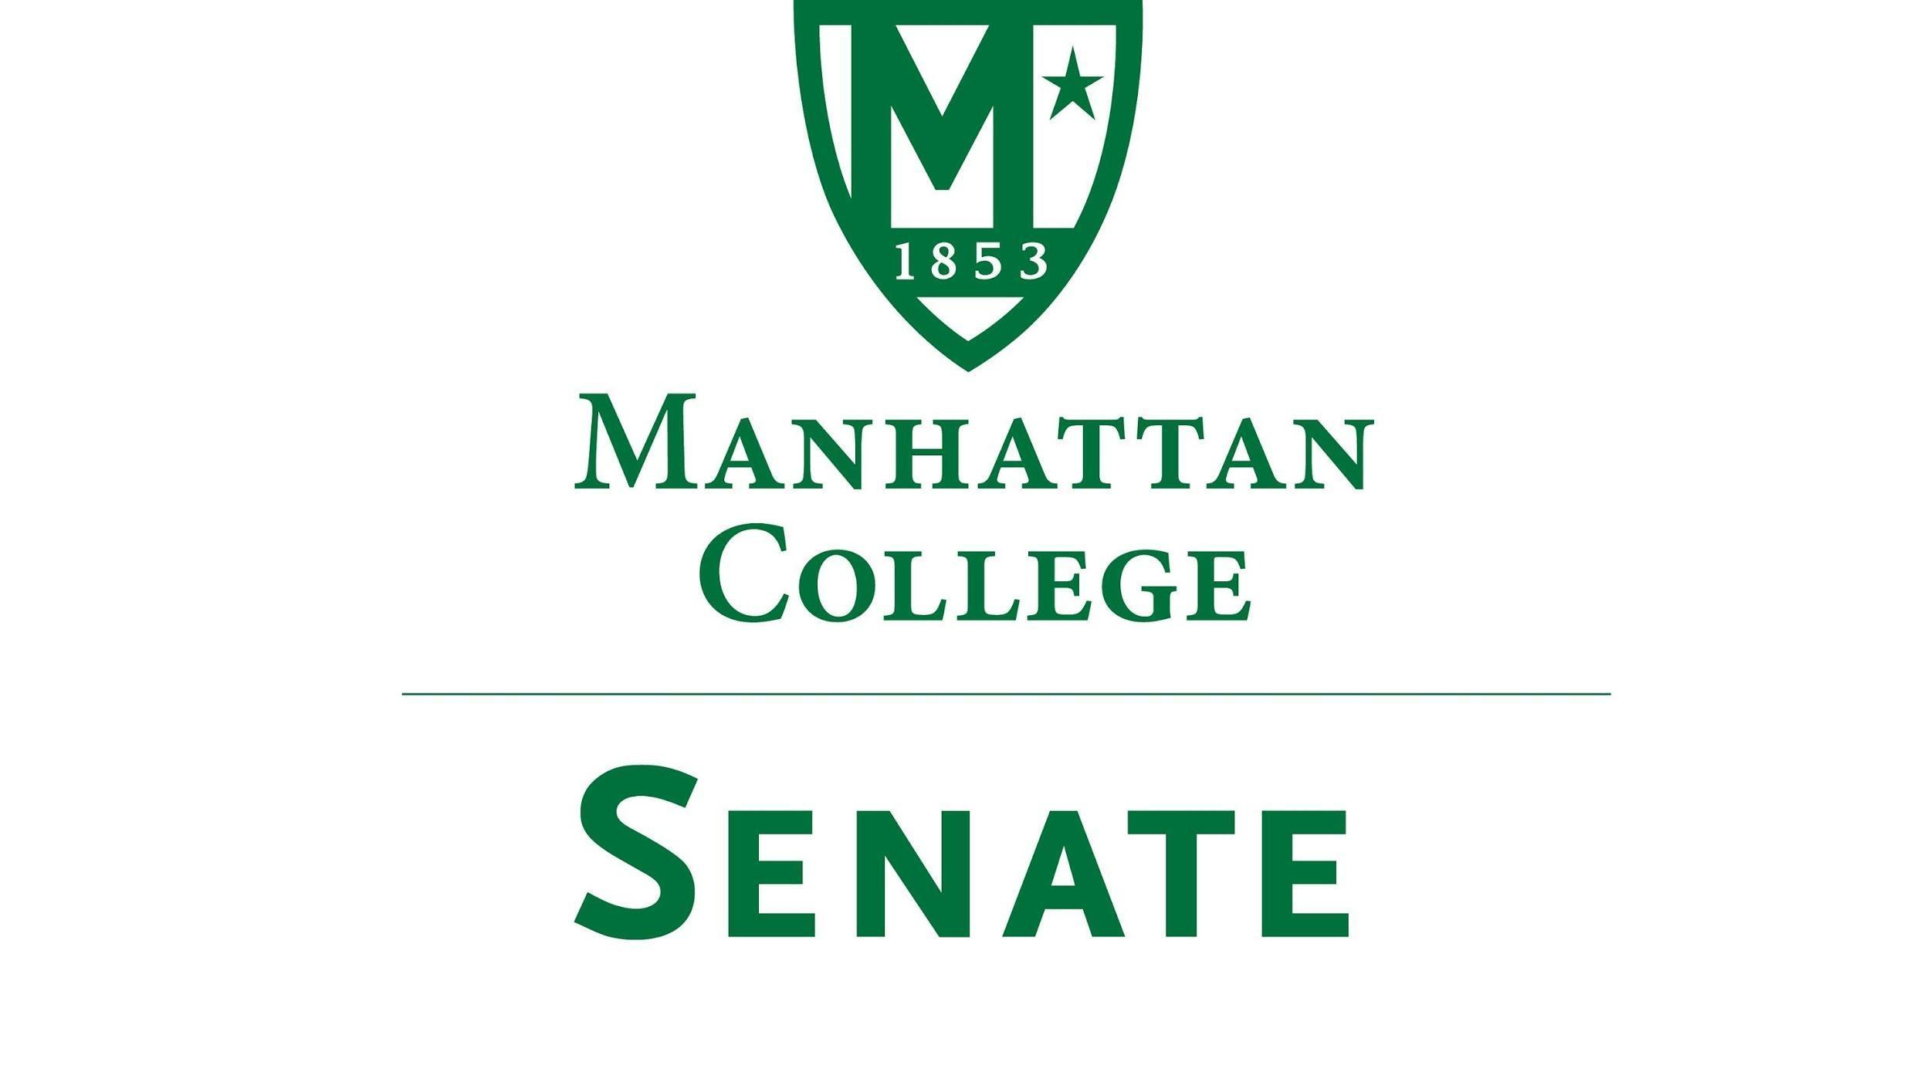

Tuesday, September 20th, 2022 | 3:30-5:00 pm | Kelly Commons, Room 5A
Recording: https://drive.google.com/file/d/1rdhIQl2umgJwGPr23vgryy4q60q6-Tv9/view
Minutes
- Roll Call
  - Present: Speaker Richard Gustavson, First Deputy Speaker Cory Blad, Second Deputy Speaker Marin Bultena. Secretary Nicole Rodi, Senator Sonny Ago, Senator Ronald Gray, Senator William Clyde, Senator Tim Ward, Senator Michael McEneney, Senator Amanda Sanserverino, Senator William Merriman, Senator Tracy Lahey, Senator Swaminathan Krishnan, Senator Bahareh Estejab, Senator Maeve Adams, Senator Courtney Bryant, Senator Kashifuddin Qazi, Senator Amy Handfield, Senator Syrita Newman, Senator Kevin Nipal, Senator Corey Curran, Senator Luca Villani, Senator Jazi Riley, Senator Chris Belden, Senator Ashley Lawton
  - Absent: Senator Enrico Forti, Senator Mackenzie Lauture
- Approval of the Agenda
  - The agenda was approved by a quorum
- Approval of Previous Minutes
  - The minutes were approved by a quorum
- Reading from the “Green Book”
  - “Always address people by their names and with great respect” St. John Baptist de La Salle
- Speaker’s Report
  - Speaker Gustavson welcomed everyone to the first official meeting of the Senate for AY 2022-2023
  - Speaker Gustavson noted that there is an open position on the Board of Trustees facilities subcommittee to be filled. Those interested are advised to contact him.
- Reports from the Standing Committees:
  - Educational Affairs Committee (EAC): Senator Clyde
    - Senator Clyde had no report as the EAC had not met yet
  - Campus Life Committee (CLC): Senator Ago
    - Senator Ago spoke on items discussed at the September 16th meeting
      - Introductions were made. The committee members introduced themselves and discussed what they would like to accomplish as the Campus Life Committee. Each member discussed their hopes in developing policies and initiatives that will positively impact the quality of life on campus.
      - The history, role, and function of the CLC was discussed as well as the process for which bringing concerns to the Senate was outlined.
      - The CLC is looking for ways to expand and enhance social justice initiatives, especially now that LOVE trips and other service-learning excursions have been revilatiled post pandemic. Additionally, the CLC looks to promote health and wellness initiatives in light of the challenges that students now face post-pandemic
      - The most pressing item of business discussed was the need to revisit the College’s current Smoking Policy, which is outdated (2016). Senator Gray has proposed the school apply for the grant funded Truth Initiative, which provides college campuses with funding up to $20,000 to become smoke-free/ vape-free.
        - Senator Ago and Senator Gray have proposed this opportunity be discussed at Senate-level
        - Given it took much time developing the latest Smoking Policy this matter is rather pressing, the deadline to apply for the Grant is October 12th
        - In the past the college had conducted a campus-wide survey. This could be done but it will take time
        - At this point Senator Ago opened the floor to discussion regarding how the CLC should proceed with this process. Both he and Senator Gray responded.
          - Is this an annual grant?
                - Yes, the Truth Initiative elicits grant applications throughout the year for funding sources.
          - Senator Courtney Bryant asked: In order for us to be eligible for the Truth Initiative grant do we need to be a smoke-free campus?
                - Yes, the purpose of this would be to promote being smoke-free
          - Senator Clyde: Are you looking for a motion from the Senate and is there a wording of motion that you would like written up?
                - Yes, CLC is looking for a motion to proceed without conducting another survey
          - Senator Adams moved to have the CLC proceed with applying for this grant without plans to conduct a survey
            - Senator Krishnan seconded the motion
          - Senator Nipal recommends we open this topic to a conversation rather than just moving forward directly
          - Senator Clyde asked to clarify that in doing this we will be a smoke-free campus.
                - Yes
          - Senator Bryant asked: what kind of provisions will be made for those who are addicted to nicotine?
                - Part of the initiative will address that in terms of providing funding.
            - Follow up: What are we going to do? Once we make this a smoke-free campus we create a problem for those who are addicted to nicotine. What happens to those individuals when they now have nowhere on campus to smoke? These people will need to go somewhere to smoke, what are the consequences if they do not leave campus?
                - These questions were brought up 6 years ago leading to the creation of designated smoking areas, thus these types of questions give reason to conducting another survey
          - Senator Nipal thinks that a survey should be conducted
          - Senator Bryant asked what is the largest amount of money we could get from this grant?
                - $20,000
          - Senator Clyde stated that this is a question of being a smoke-free campus or not. There are costs for people that are smoking and there are costs to people that are not smoking. He also made a note that there are other campuses that are smoke-free
                - According to Senator Ago, most campuses in NYC are smoke-free.
          - Senator Bryant asked, what does it mean to be a smoke-free campus?
                - No smoking anywhere on campus
          - Senator Adams asked what the process is now that this topic has been proposed? Are the senators to bring this to their constituents to then have another discussion regarding their concerns?
          - Senator Qazi asked for clarification on what it means to be smoke-free
                - No cigarettes, no e-cigs, and nor vapes
          - Speaker Gustavson raised the idea of bringing this topic to the senator’s constituents before moving forward
          - Senator Clyde suggested we table the motion until the next meeting, Senator Ward agreed this may be the best way of doing it
          - Senator Byant got confirmation that a survey has not been conducted in 6 years
          - Senator Riley asked that if we table the motion till the next meeting, will we miss the deadline for applying for the grant?
                - Yes, the next Senate meeting is October 18th and the deadline is October 12th
          - Senator Adams asked: Can we apply for the grant without declaring smoke-free but with plans to run a survey
                - The initial piece of the grant is to develop a task force that will then either conduct a survey or perform a bud count (count the cigarette buds across campus). The initial request for the funding is to begin the process of a smoke-free campus
          - Senator Ward suggested the motion be withdrawn
          - Senator Adams withdrew the motion
            - Senator Krishnan withdrew his second
          - The CLC with begin the process of applying and the topic will be further discussed at the next Senate meeting once senators have had the opportunity to relay the topic to their respected constituents
- Old Business
  - none
- New Business
  - President Gardner’s State of the College Address
    - President Gardner thanked the Senate for the invitation to speak
    - He began by relaying the 3 questions proposed to the Cabinet at the opening retreat this past summer:
      - How does the decision that we are about to make demonstrate excellence for Manhattan College? Not for my division, not for my department, not for my school.
        - The intent of this question is the elimination of silos and a greater impact of our life together as an overall community rather than just thinking about my local group. What is good for you is good for me.
      - How does this decision, project, program, email, conversation, voicemail, or memo project a true sense of customer service?
        - This is a very important aspect of Manhattan College in a competitive enrollment environment. Following along with our mission, customer service means valuing one another.
      - How is this decision witness to Catholic and La Sallian values?
        - Whether it be building a sense of community, evangelization, a care for creation, social justice or any other core La sallian values.
    - The Cabinet has been asked, from a 300,000 feet view, to consider everything that they have planned to do this year using those three questions as a lens to look at the goals for that.
    - President Gardner also hopes these three questions will help him accomplish his major goals on campus this year.
      - To foster a campus environment that will be attractive to new and permanent leadership and thus shepard the process for a new president and new provost
        - Leadership is our interesting question this year given our significant changes in high level administration. This can be fear inducing as process, roles, and objectives may change
          - Roles changed: Chairman of the Board of Trustees, President, Provost, VP of Student Life, VP of Facilities, General Council, and two new Deans
        - The processes are going to be conducted by an outside company called WittKieffer, known as the best in class for executive searches. The Board of Trustees, with input from Dr. Groarke and the CFA, wi;; put together the timeline for this project. We need to make sure that the college is in a stable place when we begin this process to ensure we are an attractive campus environment for the best candidates. We need to attract the best because we are the best. We want to continue that tradition into the long term future.
      - Accountability and transparency, which in a larger sense, comes across as shared governance in many people's minds to which President Gardner agrees. This is a matter of us holding one another accountable; telling people what your heart is saying in a respectful way at all times. For those in leadership roles, they should be willing to listen to what people are saying. Colleagues, students, and administrators holding one other accountable for excellence.
        - A part of this is shared governance therefore Senator Clyde as well as various constituents across campus are working to produce the proper language for what this means at Manhattan College
      - An effective analysis of our organization chart to make sure that, in these post covid days where so much has changed, all of the previous positions that we have had are meeting the needs of what the new Manhattan College requires in order to be a place of excellence
        - This does not mean we are getting rid of positions because they are not needed. But we do need to be very clear about purpose and the repurposing of the various tasks around campus to ensure that all of the essential workings of Manhattan College are covered officially in one way or another.
        - Human cost analysis has been in motion in collaboration with members from the Board of Trustees, administration, the Institutional Advancement office, and the Finance office to determine how much it actually cost to attend Manhattan College in each major and in each school. This info will give a clear idea of how much effectively to disperse resources across campus
      - Facility enhancement; if we do not look excellent then no one on the outside will think we are excellent. Therefore, we need to put our best show on at all times across campus. Making things look nice is a major priority to President Gardner
        - Immediate cosmetic enhancements include:
          - Alumni Hall: top floor renovations due to water damage and new roof installed. Next two phases include pointing the walls to prevent more water damage and new windows.
          - Indiscriminate tree falling has led to multiple trees being removed across campus. The trees on the quad will be replaced mid fall
          - Scaffolding in front of the dormitories on the main campus has been removed. Power Washing has been done
          - Newly renovated music room in Thomas Hall
          - Draddy Gym renovations
          - New carpeting in the Library
        - In terms of long-range facilities, we are to bring our focus back to the campus masterplan. The next steps include:
          - Enhancement of residence halls
            - Chrysostom hall is being renovated and is set to reopen for the Spring semester of this year
            - Horan hall, the largest residence building, will be closed from December 15th till August 1st. It will be completely gutted and turned into a mix of apartments and suite style living. Funding is set to come from the sale of Overlook Manor
            - Work on Squeri Hall will begin shortly
      - Customer service image: we care about one another, we care about property, and we care about our programs. Feeling of community, sense of respect and interest in one anothers goals and objectives.
        - Emphasis of faculty, increased gathering spaces on campus, and many more community building based projects coming
    - Practical matters
      - Enrollment was above budget for incoming freshman; 765 as opposed to the budgeted number 750
        - Average incoming GPA was 90.2, average SAT was 1232
        - One concern to be monitored is the melt of students between their first and second year; increase from 7% to 10%
      - Return of benefits and quality raise for faculty, staff, and administration. The goal is to have a full match for benefits by the end of the year and a decent wage increase
  - Question and Answer following President Gardner’s Address
    - Senator Newman: What is the plan for the empty space by Leo and Higgins buildings?
        - Initially that was space for an additional dormitory however we do not need additional capacity at the moment. Instead, an attractive fence may be put up and leveling may occur in the meantime. The facilities committee will begin to reevaluate the masterplan and brainstorm that space
    - Senator Bryant: Where are we in the process of selling Overlook?
        - The building is listed with bids but none have been accepted yet
    - Senator Adams: What is included in the unit cost analysis?
        - Tuition would not change but it would give an idea of how much it costs each student depending on their study. It would include labs, classroom instruction, services (career development, counseling center).
    - Senator Adams: Do you also plan to include a market analysis of those degrees or is this strictly about how much it costs to provide support and instruction?
        - Support and instruction
    - Senator Nipal: What role will shared governance be in the hiring of the new president
        - Administration will not be involved in that process at all therefore ideas will be coming from community members and Board of Trustees. This will reflect the views of what the President should be from the bulk of the community
        - The process would be that currently the Board of Trustees, working with the CFA, are getting representatives for the search committee. The Board of Trustees has also been working through John Bennett and SGA to have student representatives on the search committee. There will also be middle level administration and cabinet level administrative on the search committee. Next will be constituent based listening sessions (town halls) for students, faculty, staff, administration, and alumni. WittKieffer will produce and publish a job description based on the thoughts and concerns heard at said listening sessions. The proper candidates will be reviewed by the search committee
    - Senator Adams: Is the shared governance committee the same committee
        - Senator Clyde: Yes. There was a self-directed work team that he met with to check in on what had been done. They were encouraged to wrap up their thinking to provide their recommendation for the proper language in the next few weeks to be shared.
  - Other
    - Senator Krishnan would like a discussion on facilities and why so many requests for work are not being fulfilled be brought to the Senate.
      - Senator Cyde recommends that the new VP of facilities be invited to the next Senate meeting to discuss his plans for the coming year.
      - The agenda committee will proceed with this recommendation and put forth that invitation
    - Senator McEneney requested that another microphone be used in the room to ensure that those joining remote can hear the discussions more clearly
      - Speaker Gustavson will see to this
- Adjourn
  - The meeting was adjourned at 4:32pm. The next meeting will be held on October 18th.

