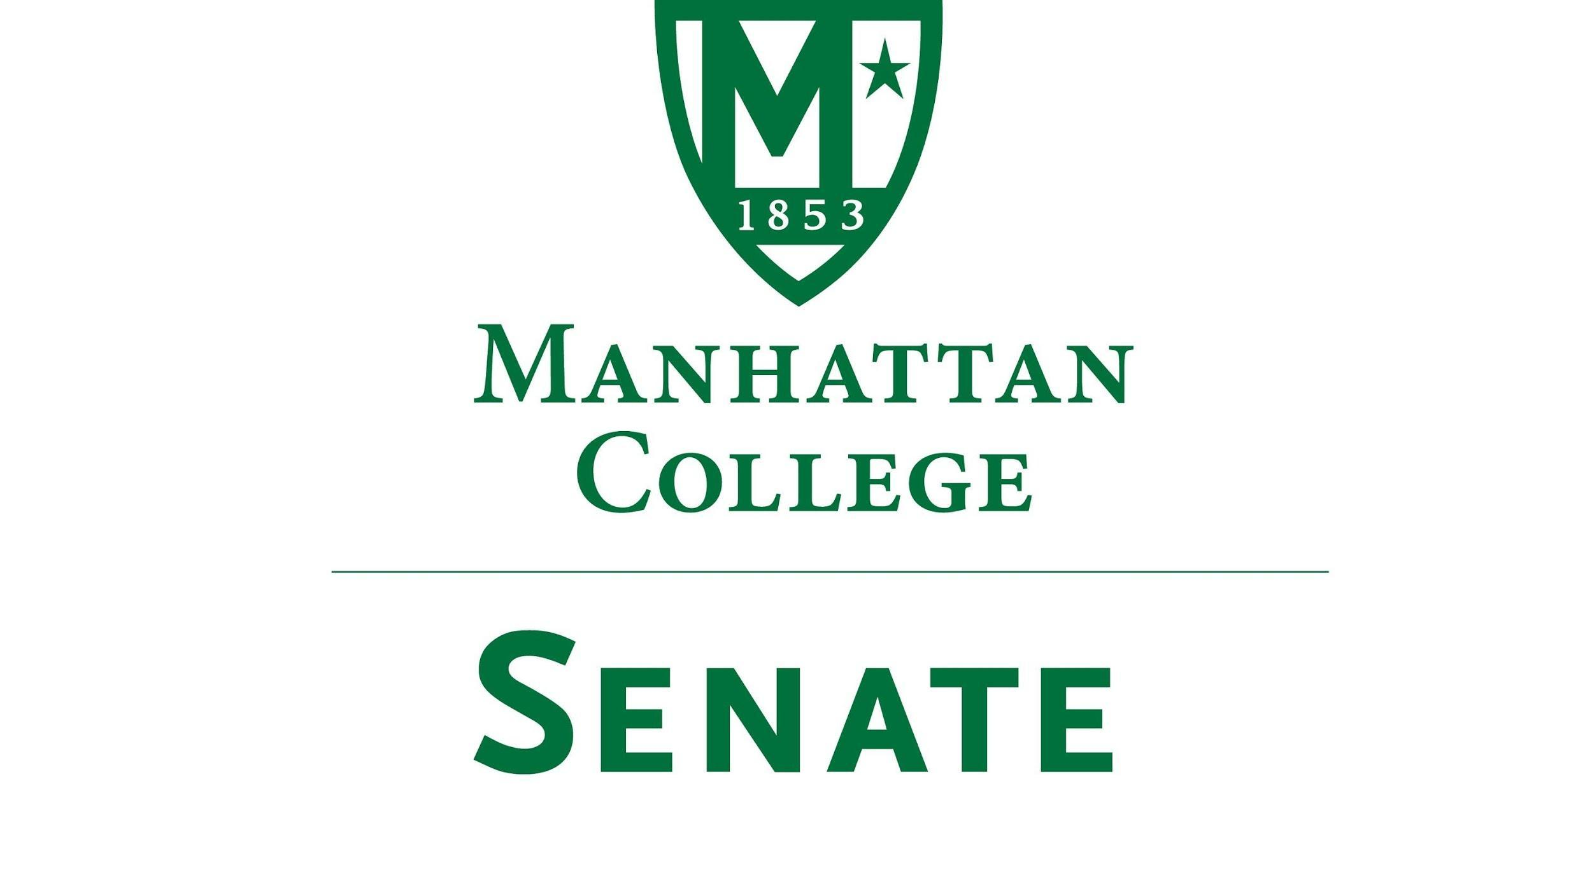

Tuesday, April 19th, 2022 | 3:30 - 5:00 pm |
Alumni Room, O’Malley Library
Recording: https://drive.google.com/file/d/190YtBnm9YaD1JELV_DuTXx1l_mNCz5eI/view
Agenda
- Roll Call
  - Present: Speaker Amy Handfield, First Deputy Speaker Tim Ward, Second Deputy Speaker Lina Baroudi, Secretary Nicole Rodi, Senator Steven Schreiner, Senator Karen Nicholson, Senator Michael McEneney, Senator Swaminathan Krishnan, Senator Maeve Adams, Senator Michael Quinn, Senator Richard Gustavson, Senator William Merriman, Senator Trace Lahey, Senator Sarah Wacker, Senator Syrita Newman, Senator Kevin Nipal
  - Absent: Senator Esmilda Abreu, Senator Juliette Rodrigues, Senator Pat Brady, Senator Matthew Carrigy, Senator Emma Piazza, Senator Marin Bultena
  - Excused Absence: Senator Sonny Ago, Senator Min Jung Kim, Senator Enrico Forti
- Approval of the Agenda
  - The agenda was approved by a quorum
- Approval of Previous Minutes
  - The minutes were approved by a quorum
- Reading from the “Green Book”
  - “Education is all the matter of building bridges” Ralph Elison
- Speaker’s Report
  - Speaker Handfield had no report
  - She will discuss under new business the election meeting
- Reports from the Standing Committees
  - Educational Affairs Committee (EAC): Senator Schreiner
    - Senator Schreiner spoke on items discussed at the April 5th meeting
      - College-Wide Curriculum Committee: Reviewed and approved two proposals: (1) School of Continuing Professional Studies’ proposal for a new Masters degree in Healthcare Informatics (2) A concentration in Aerospace for Mechanical Engineers
      - The College Technology Committee and the Graduate Council did not meet
      - College Library Committee: The library will launch a New Research Celebration in Fall 2022. It will include staff and faculty research. Planning is underway
      - Old Business: The President approved both the Dismissal Appeal Policy and the SCPS Transfer Policy Proposal
      - New Business: A proposal for online course definitions was brought forth
        - Online asynchronous- taken off-campus, on the individual’s time
        - Online synchronous- individuals are presently online at a set time
        - Blended- online with in-person components
          - Blended is a more clear and universal term to identify this course as opposed to hybrid
        - Online vs. Blended Program
  - Campus Life Committee (CLC): Senator Ago
    - Senator Ago had a conflict of interest and was therefore excused (sad because this is the first meeting of the Senate he has missed)
    - The CLC was unable to meet; this is common come the end of the Spring semester
- Old Business
  - None
- New Business
  - May 3rd Election Meeting
    - The current meeting is the last official Senate meeting of the academic year
    - The next will be our election meeting
      - Traditionally meets on the first Wednesday of May
      - An invite will be distributed for May 3rd from noon to 1 pm
      - It will be held virtually
      - The only point of business will be to elect officers for the coming year: Speaker, First Deputy Speaker, Second Deputy Speaker, and Secretary
      - Current senators and new senators are invited to attend
      - Ways to nominate: self nominate and nominate someone else
    - First Deputy Speaker Ward
      - Due to overlap in scheduling with the meeting of the Graduate Council, this election will be held efficiently to account for members of the Senate who will be in attendance at both
  - Remarks from President O’Donnell
    - President O’Donnell spoke on items outlined in his Overview of Goals for the 2022-2023 Academic Year
    - President O’Donnell thanked the Senate for the invitation to discuss such topics as we anticipate the coming year
    - He noted that this discussion is not an attempt to touch on everything that is important and that needs further support from the college. He will not discuss the shared governance working group although it is an area that is of utmost impotence for the coming year.
    - This presentation is limited to the specific nature of new strategic initiatives that are being brought forward in the college’s strategic plan and in support of the November planning document, Patch Foward. This provided an overview of how the college is responding to the many challenges we have been through in the past two years
    - The presentation includes headlines from the Task stream, recommendations from various self-managed work teams, and information coming out of the Middle States process.
      - Kudos to those involved in the Middle States process
      - Should be heartened by the assessment due to the rigorous peer assessment undertaken in response to a very serious self-study being done over the past two years. Ringing affirmation of the college’s efforts since the last accreditation.
      - We meet the standards for re-accreditation and thus congratulations to those involved for their work well done. There was explicit praise for the OneManhattan initiative and the financial management of the college over the past two years.
      - Through the praise, the college intends to continue moving forward in accommodating the serious recommendations for improvement coming out of the assessment
      - Kudos to the working groups and working group chairs as well as Kelly Marin, Ronny Roy, and Bruce Libby
      - Teams assessment is not yet official. We will not have an official announcement to make about the college’s accreditation until after June 6th
    - Academic Affairs
      - Encouraged to read the Patch Foward document as it pertains heavily to the items related to academic affairs
      - Continue to diversity our academic programs to address programs to address emerging needs of students
        - Increase graduate enrollment through new programs as well as adapting existing programs to student needs by providing high-quality online pathways. Potential new programs include healthcare informatics, corporate and organizational communications, as well as exploring interdisciplinary degree programs related to data science
        - Create a Structure for the Graduate Program Enterprise based on recommendations of the Self Managed Work Team supporting the Strategic Plan’s goal to increase graduate enrollment
        - Strengthen pathways for transfer recruitment and enrollment, including increasing the number of transfer articulation agreements
      - Develop a New Center for Global Engagement, in collaboration with the Student Life and Enrollment Management, to create a seamless experience for all stakeholders and increase our engagement with both Lasallian and strategic global partners on all levels
      - Continue to build upon and promote established Programs and Centers of Excellence, including Community Engaged Learning (CEL), the Holocaust, Genocide, and Interfaith (HGI) Education Center, student opportunity programs, and the Veterans Center
      - Increase Strategic Use of Data across campus
      - Improve undergraduate student retention and enrollment
        - Create an office of First-Year Experience that enhances and complements the existing experiences on campus and in each school
        - Improve systems for identifying students in need of support, including collaboration with academic departments to offer integrated academic support for gateway courses
        - Investigate new undergraduate majors and minors
    - Student Life
      - Continue to foster inclusive community building; for example, the development of shared-interest “hubs” promoting diversity, inclusion, and student belonging
      - Continue to build on the Well-campus initiative through the Well-being and Flourishing Council
      - Continue to assess and refine Health Services processes, access, and messaging to meet changing needs of the community
      - Work with facilities and finance to upgrade and diversify existing housing stock and plan for the next phase of residential facilities and program development
    - Mission
      - As per the Middle States Self-Study recommendation, establish the mandate and inaugurate the “Mission and Core identity Advisory Committee”
      - Also issuing from our Middle States review: support the faculty in incorporation a robust, accessible, and explicit understanding of belonging as a part of the Lasallian Catholic core identity of the college within the learning objectives of the First-Year Experience
      - Work with HR and others to elevate the diversity, equity, inclusion, and belonging aspects of recruiting and onboarding by making them more robust, explicitly identified as part of the Lasallian Catholic core identity of the College, and systematically embedded into HR protocols
    - Enrollment Management
      - Continue to build structures and processes to achieve aspirational but realistic enrollment goals in an environment of change and diversification of student demand
      - Continue to strengthen traditional undergraduate enrollment through targeted strategic marketing and EM best practices at every point in the recruitment funnel
      - Increase enrollment of qualified transfer students including:
        - implementation of recommendations from the Transfer Self-Managed Work Team
        - Develop a better credit respiratory and assess Manhattan’s status for alignment with best transfer practices
        - Work with Academic Affairs to increase articulation agreements
      - Increase awareness of Manhattan College as a Military Friendly institution
      - Increase international student recruitment
        - India and Saudi Arabia
    - Intercollegiate Athletics
      - Develop a strategic, multi-year plan for tiering varsity sports, balancing staff and facilities to counter our peers within our conference
      - Maintain focus on providing the best student-athlete experience while balancing the expectations of enrollment management and the College’s discount rate
      - Optimize the Manhattan College brand to recruit and retain student-athletes, coaches, and staff
      - Emphasize revenue generation through targeted fundraising, facility rentals, corporate sponsorships, and ticket sales
    - Finance and Administration
      - Expand our Five-Year Operating and Capital Budget Model Pro Forma which integrates Strategic Initiative with Realistic Data Analytics
      - Develop a long term Capital Plan utilizing Privatization strategies and progressing bond issue projects
      - Continue to expand and develop core business services to enhance the Student Experience
      - Address the immediate need to upgrade and diversify residence facilities, develop a financing plan for Horan renovations
    - Human Resources
      - Training and Professional Development: continue Title IX training, as well as supervisory and leadership development
      - Onboarding: completely revamp and deep onboarding Processes for new employees, Involving other departments in the process
      - Retention: in addition to the above goals and policies, add policies that grant employees the ability to work in a hybrid environment
      - work with compliance with federal, state, and city regulations and continue to improve whistleblower policies
      - transfer all HR policies to Policystat
    - Marketing and Communication
      - Evaluate the effectiveness of all marketing and communication areas through data-driven and other relevant monitoring methods
      - Promote brand identity to increase awareness and establish Manhattan's reputation as a higher education leader in New York the metro area and beyond
      - Implement an integrated approach to marketing and communication across divisions, departments, and/or groups of the college
      - Develop and implement marketing and communications activities, campaigns, assets, and digital platforms to increase student enrollment and retain current students
    - Office of Advancement
      - Alumni Relations
        - Advance the college's mission by creating a life-long and worldwide alumni community through local, regional, and international events that increase awareness, pride, participation, volunteer involvement, and philanthropic commitment to Manhattan College. Increase total alumni participation in events at least 5%
      - Capital Campaign
        - Achieve all campaign fundraising goals, driving our fundraising efforts with strategic and broad-based outreach to all alumni and friends of Manhattan College. Drive the already record-breaking campaign to and potentially Beyond $190 million. position for declaring success in 12 to 8 months
      - Development
        - Raise $4 million in unrestricted cash to balance the college's operating budget
      - Heartfelt regard from the Senate to President O’Donnell for his leadership. We wish him well in the next phase of his career
  - Matthew Mcmanness
    - Update regarding Financial Planning
    - Deficit of $2.3 million
    - Community Update adjustments
      - Positive revenue projection, financial aid is lower
      - Lower discount rate for next year’s freshman class
        - The financial aid package should bring a discount rate about 2 lower than the current year
      - Resident rate improved by $1.8 million
      - Anticipate an over annual fund of about $1 million
      - Graduate revenue continues to reflect a shortfall of about $2.7 million
      - Several expense adjustments have affected the operative budget
        - Retirement increased the expense of the benefits by $1.7 million
      - Cost center managers; nail down the current year and project for the future year
      - Identify the priorities of the budgeting committee’
        - Includes salaries and major priorities
      - A new update will hopefully be provided shortly
      - Thank you to the Senate
- Adjourn
  - The meeting was adjourned at 4:34 pm. The election meeting will be held on May 4th

