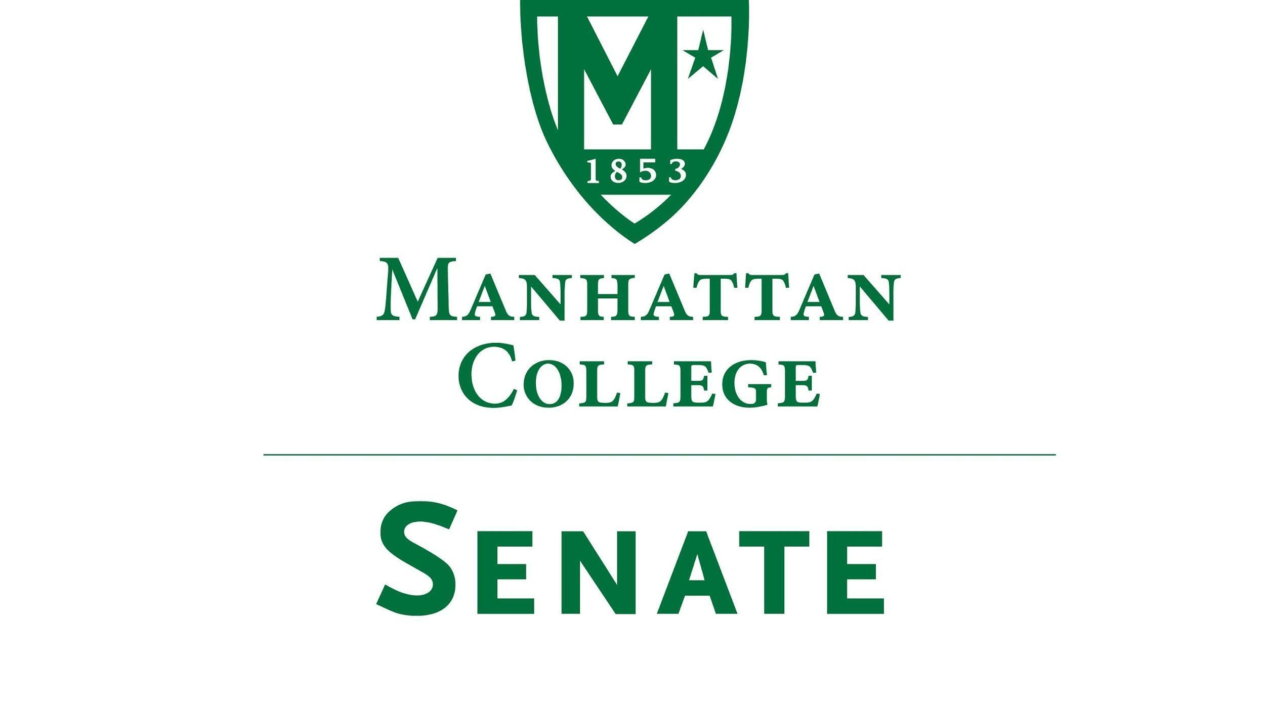

Tuesday, October 18th, 2022 | 3:30-5:00 pm | Kelly Commons, Room 4C
Google Meet Recording: https://drive.google.com/file/d/1bAvYNNux9E9XzF9b4LzXEgGe42cNcsK_/view
Minutes
- Roll Call
  - Present: Speaker Richard Gustavson, First Deputy Speaker Cory Blad, Senator Sonny Ago, Senator Ronald Gray, Senator William Clyde, Senator Michael McEneney, Senator Amanda Sanseverino, Senator William Merriman, Senator Tracy Lahey, Senator Swaminathan Krishnan, Senator Bahareh Estejab, Senator Maeve Adams, Senator Courtney Bryant, Senator Kashifuddin Qazi, Senator Syrita Newman, Senator Kevin Nipal, Senator Justin Orr, Senator Corey Curran, Senator Jazi Riley, Senator Chris Belden, Senator Luca Villani
  - Absent: Second Deputy Speaker Marin Bultena, Secretary Nicole Rodi, Senator Enrico Forti, Senator Amy Handfield, Senator Mackenzie Lauture, Senator Ashley Lawton, Senator Ali James
- Approval of the Agenda
  - The agenda was approved by a quorum
- Approval of Previous Minutes
  - The minutes were approved by a quorum
- Reading from the “Green Book”
  - “Never speak to anyone except with kindness and if you dare to speak otherwise keep silent” Saint John Baptiste de Lasalle
- Speaker’s Report
  - Nothing to report
- Reports from the Standing Committees:
  - Educational Affairs Committee (EAC): Senator Clyde
    - Senator Clyde spoke on items discussed at the October 4th meeting
      - Cut tests: current policy states that students can only take these tests before coming to Manhattan College. The current consideration is whether targeted adult learners would be allowed to take these tests once matriculated here. This topic will be discussed further
  - Campus Life Committee (CLC): Senator Ago
    - The CLC did not meet however Senator Ago spoke on topics of discussion
      - The school has applied for the Truth Initiative Smoke-Free Grant; $20,00
        - This does not declare the campus smoke-free or vape-free but it is a part of an exploratory process to see whether or not this would be a viable option for us. Part of this process is to gather the information, create an educational outreach plan on the health risks of smoking and vaping, and think about the certain ways we can either change our policy or maintain it. This is the start of a year-long journey. A task force consisting of many individuals from different sectors will be formed.
        - Senator Merriman maintained that the task force should include faculty members to which Senator Ago agreed
      - Senator Ward brought to the Senate that Senator Ago has received a new job, therefore he would like the minutes to reflect our appreciation for his hard work over the past several years especially through his dedication to the students. A round of applause for Senator Ago was awarded.
        - Senator Ago appreciates the Senate’s well wishes and his time spent at Manhattan College. The work conducted in the Senate for the past decade and the friends made will be missed. He will be aiding Dr. Gray in the search for his replacement.
- Old Business
  - None
- New Business
  - Update on College Facilities by Vice President Collins
    - Ongoing big capital projects include:
      - Facade repair projects at Lee and Horan Halls
      - Squeri Hall will have new sidewalk shedding for repairs on the coppola
      - Extensive interior renovations in Chrysostom Hall valued at $3.9 million. Rehabbing the entire interior of the building as well as the HVAC systems. To be completed by the middle of December which will lead students out of Horan Hall and into Chrysostom Hall
      - Horan Hall will be undergoing massive renovations from January 2023 to July 2023; valued around $10-$11 million.
      - Overlook Manor work will be completed in the next week. Once work in Horan is completed in July, students who reside in Overlook will be moved there.
    - Smaller capital projects include:
      - New Veteran Center
      - New music room in Thomas Hall
      - New men’s restroom in Memorial Hall
    - Questions
      - Senator Qazi asked for the parking garage’s Broadway door to be accessible. This access point is especially useful for those going to the buildings on South Campus.
        - The gate will remain closed for security purposes but the facilities team can look into making sure that the door is operational for those who would like to use it. VP Collins recommended that an email be sent to him regarding further discussion of this.
      - Senator Merriman had a question regarding the facade of Draddy Gym
        - The unattractive overhang will be dealt with pending an architect's report with solutions for long-term changes.
      - Senator Qazi asked if it would be possible to reinitiate routine facilities communications with the campus community to know what facilities projects are being pursued and their estimated dates in the same manner as has been done in past years
        - There is a new policy for dealing with new projects, an intake process that gets done by the facilities committee. VP Collin requests that an email be sent to him with the explicit askings.
        - Senator Qazi and Speaker Gustavson clarified that the community is asking for periodic updates on facilities projects to ensure that everyone is in the know of what work is being done campus wide
        - Senator Clyde suggested that VP Collins have his faculty send a communication to all employees at the end of October
      - Rehan Mehta brought to the table a discussion of the College’s plan to improve accessibility. He pointed out multiple instances where buildings are completely inaccessible to those with physical impairments as well as the daily challenges of getting around this campus due to its abundance of stairs and non-functional elevators.
        - Accessibility will only be included in the major capital renovations. Any building not on that list will not be getting ADA accessibility updates
        - Rehan followed up by asking how are students who are currently not proper abled expected to get around campus
        - VP Collins suggested that work orders be submitted regarding those specific areas that may need updating to meet those concerns
      - Senator Krishnan asked if there is a plan to do an inventory of the buildings across campus, especially Leo, to assess the needs and repairs of rooms
        - There are some plans to deal with the HVAC systems in Leo however not in the immediate future. Other concerns can be fixed through work orders
        - Senator Krishnan noted that there are multiple equipment and technological issues across buildings and yet there is little movement; this is the concern of faculty.
        - VP Collins policy with work orders is that if in 3-5 days there is no response, then he can be reached directly to ensure it is taken care of.
      - Will the renovations made to Chrysostom include accessibility updates?
        - Not required to create a new ADA entrance to the building so the renovations do not include a handicap entrance
  - Update on College Finances by Vice President McManness
    - VP McManness thanked the Senate for inviting him to speak on the College’s Operating Budget and Capital Gains. He noted that it is still early in the year thus there is much work to be done on the budget as the year progresses
    - FY 2023 Operating Budget Projection- Current Results
      - The projected freshman class was 750 with 150 transfer students
      - The projected and modeled discount rate was 62.6% for freshman with a 53% overall
      - 2,900 total students
      - 1,350 students in residence
      - Other tuition reflects a significantly lower revenue level with a 726,000 projected shortfall
      - Graduate revenue was projected to be $1 million below budget
      - Auxiliary Programs have resumed revenue rates back to pre-pandemic levels
      - Continue the Endowment Spending rate at 5%
      - Four total FEMA funding applications in review
      - A compensation adjustment of 2.5% and an increase in the retirement contribution of 25% to make the total contribution 75% of the benefit was implemented. In the spring there were 78 positions held- currently there are 44 vacancies- Projecting as $1.7 million overrun
      - General Operating Funds- projected overrun of $600,000
      - Utilities- adjustment for Higgins and Leo Facilities - $236,000
      - Small increases in the Marketing budget and the Capital Budget
      - With the already existing deficit of $2.5 million and including this updated projection with the noted additional adjustments, the College is projecting a $7.5 million deficit. (Includes offset Revenue from Donations and Auxiliaries)
        - This may seem frightening however the College has processes in the case that additional funding is needed (equity and credit)
    - Senator Merriman asked when the full pension will be reinstated?
      - There will be an extensive discussion about this budget at the upcoming board meeting, however VP McManness can not state whether the full pension will be handled this year or if it will be a part of the projection and request for next year
  - Other?
- Adjourn
  - The meeting was adjourned at 4:19pm. The next meeting will be on November 15th

