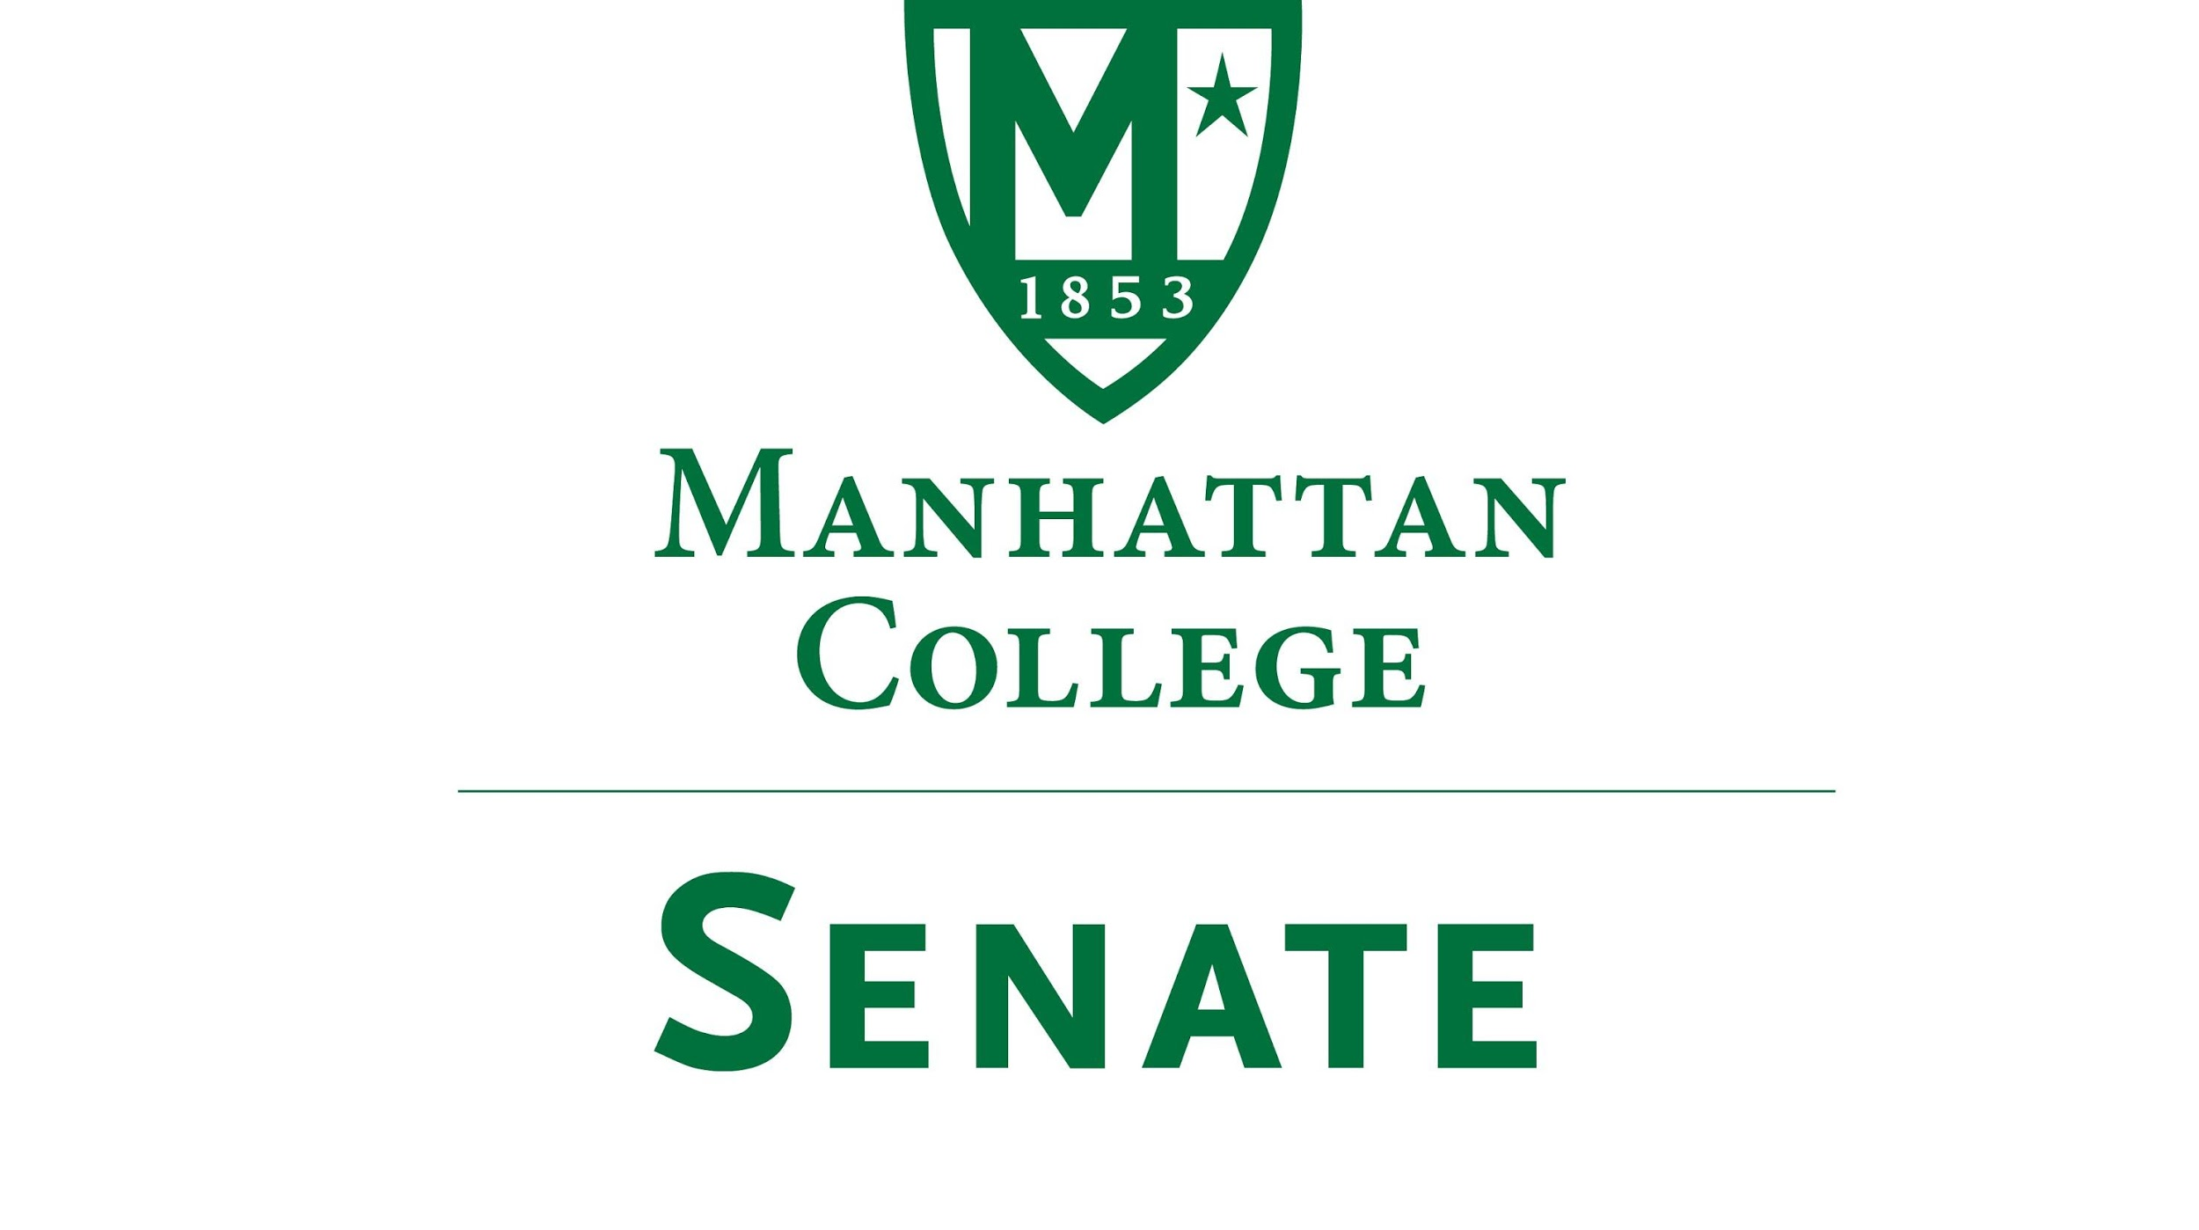
Tuesday, April 18, 2017 | 3:30pm | Kelly Commons 5A
Minutes
- Roll was taken.
  - Senators present: Amira Annabi, Ankur Agrawal, Sonny Ago, Salwa Ammar (Janet Rovenpor present as substitute representative), Keith Brower, Shawna BuShell, William Clyde, Antonio Cordoba, Nuwan Jayawickreme, Matthew Jura, Peter McCarthy, Michael McEneney, Margaret McKiernan, Carolann O’Connor, Kaitlyn von Runnen, Richard Satterlee, Jessica Wilson, Qian Wang, Crystal Xu
  - Senators not present: Micaela Bishop (excused), Dana Coniglio, Fionnuala Duffy, Amy Handfield, Kyle Meany, Joseph Moussa, Lisamarie Nilaj, Francois-Xavier Thiolliere, Kevin Welsh
  - Quorum was met.

- Meeting called to order by Speaker Jura at 3:35pm.
- Approval of the Agenda
  - Motion passed
- Approval of Previous Minutes
  - Motion passed
- Reading from the “Green Book” pg.5
- Speaker’s Report, Speaker Jura:
  - Elections Meeting for next year’s Senate Executive Positions: May 5th, 2017, 12pm-1pm, Kelly Commons 5C; please attend to make Quorum
  - Positions are Speaker, 1st Deputy Speaker, 2nd Deputy Speaker, Secretary--descriptions of positions can be found in the Constitution and Bylaws

- Presentation on the Strategic Initiatives, President Brennan O’Donnell
President Brennan discussed the new strategic plans available to all in Taskstream:

Users of Taskstream are able to log on to see what chairs, program directors, deans, and vice presidents are proposing as key strategic goals by going directly through their accounts to the MC Community Goals Webpage [via ‘AMS’, ‘Shared Resources,’ ‘Browse resources distributed by AMS Coordinators,’ 'Select Search,' then ‘2017-18 Manhattan College Goals’).
Those who are not Taskstream users can also view the webpage by following link: https://www.taskstream.com/ts/manager309/20172018ManhattanCollegeGoals and entering password: MCGoals1718.

An excel spreadsheet with all goals is also available for viewing through the following link: https://docs.google.com/a/manhattan.edu/spreadsheets/d/1iTivkiuSSqnTPXesGGx5uIHDgARTO6g5s5QyVvkivow/edit?usp=sharing

President Brennan and the Vice Presidents will continue to work to prioritize Goals for the coming year, comments are welcome. Please direct comments, as appropriate, to your chair, director, dean, or vice president, or directly to me at this email address. It would be most helpful to have comments by April 28.

9. Reports from the Standing Committees:
- Educational Affairs Committee: Senator Clyde Reporting (Full Report in Moodle)
  - Reminder: Graduate Fair on April 27, 2017 6:30 Kelly Commons
  - Academic Calendar for 2017-18 and 2018-19
      - The College will be observing Holy Thursday going forward.
B. Campus Life Committee: Senator Ago Reporting (Full Report in Moodle)
1) On April 5, 2017 the results were posted for newly elected members of the 2016-17 Student Government Association. The Campus Life Committee is in the process of reaching out to the new SGA Executive Board to identify and address campus life concerns in the upcoming academic year. (See Positions & Names in digital report in Moodle)
2) On March 30, 2017 representatives of the Manhattan College Commuter Students Association presented to the Manhattan College Board of Trustees Student Life Committee, in conjunction with members of the Campus Life Committee of the Senate. Students discussed their experiences and concerns. Below are the three specific areas they would like the College to address.
· Full-time administrative support for commuter students
· Designated commuter student lounge
· Coordinated commuter student “buddy system”
10. Old Business
  - Motion Regarding Crossing Between Leo and RLC Buildings: President O’Donnell has it on agenda for the administration to talk to the city representatives.
  - New Business
None.

Adjourn at 4:51 pm.

