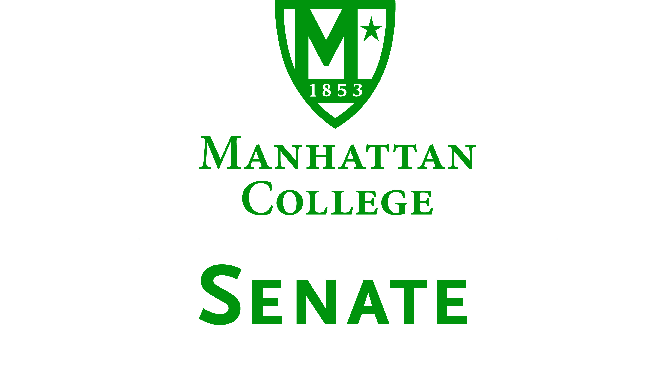
Tuesday, April 21, 2015 | 3:30pm | Meeting Room 5C, Kelly Commons

Minutes
In Attendance: Amy Handfield, Andrew Greene, Constantine Theodosiou, Giancarlo Schillaci, Goli Nossoni, Jawanza Clark, John Leylegian, Kevin Hill, Kimberly Hickey, Kudret Topyan, Kyle Karp, Margaret McKiernan, Matthew Jura, Michael McEneney, Ming Hsu, Patricia Sheridan, Paul Droubie, Peter McCarthy, Richard Satterlee, Sonny Ago, Syrita Newman, William Clyde, William Merriman.
Absent: Alex Shalian, John Tudisco, Monica Horan, Patrick McCann, William Casey.
- Roll was taken. Quorum was met. Meeting called to order by Speaker Droubie at 3:36pm.
- The Agenda for the April 21, 2015 meeting of the Senate was approved.
- The Minutes of the February 17, 2015 meeting of the Senate were approved.
- Speaker Droubie read an excerpt from p. 78 of the “Green Book.”
- Speaker’s Report: Speaker Paul Droubie
  - The next meeting of the Senate will be on reading day, May 6, at either 10am or 11am.
  - Note that Speaker Droubie will not be serving on the Senate next year.
- Presentation by President O’Donnell on the state of the college.
  - President O’Donnell is giving the annual update on the strategic plan process.
  - There will be a Board of Trustees meeting on June 11.
  - The current version of the Strategic Plan was sent out in March so the entire college community can see it.
  - Please bring any feedback you have to the Senate.
  - Note that the document indicates that we have a lot of aspirations, and we will not be able to do all of the things on the list of goals.
  - There is an increased emphasis on graduate programs and adult learning.
  - The intention is not to grow the traditional undergraduate program by much.
  - The college is moving carefully into online education to diversify what we do at the college.
  - There is an increased emphasis on service learning---more of an integration of academic learning into service.
  - There is an emphasis on the fact that we have to expand fundraising efforts (and not just from the President and the VP of Advancement, but also from faculty and other administration, such as Deans---the people who have a direct investment).
  - The goal is to have 3500 undergrads with about 2600 on campus. We currently have about 3350 undergrads (this would increase the number of students in residence).
  - There will be more of an emphasis on theme communities in residence halls.
  - Title IX issues will be addressed---not just to comply with the law, but to work to make things better.
  - Develop the programming of the Multicultural Center.
  - In the Office of Mission, a goal is to develop the College Core Identity Seminars for new faculty and staff.
  - There will be work to de-centralize the work of the Advancement Office, while still centrally planning the fundraising work.
  - There will be a new capital campaign---it will be significant and comprehensive, for facilities, endowment, and programmatic support.
  - In the Office of Enrollment Management, the goal will be to grow the student body slightly---market for the recruitment of grad students.
  - The classroom upgrade project will continue.
  - Walsh Plaza and the Quad will be under repair.
  - Stained glass in the Chapel will be replaced with a newly acquired piece of stained glass (an historic piece, which took a good deal of work to acquire).
  - Another goal is to foster wellness, through the Fitness Center.
- Presentation by Brother Jack Curran, FSC, on Phase II of the Strategic Plan.
  - The Strategic Plan Phase II is still not in its final form.
  - The vision is to have a clearer identification of major assets to be leveraged, to advance learning.
    - Assets include our Lasallian heritage, proximity to New York City, and an extraordinarily broad range.
  - The Core goals are to advance learning through our distinctive heritage, distinctive environment, distinctive dynamic.
  - The Supporting Goals of Phase I are to be integrated into key strategies and Core Goals
    - Have a qualified and diverse staff
    - Have strong tenured and tenure-track faculty
  - Goal 1 includes:
    - More of an emphasis on the spiritual development of students.
    - Extracurricular support and scope
    - Greater specificity about “Lasallian research”
  - Goal 2 includes:
    - Greater emphasis on diversity through NYC
    - A new emphasis on wellness
  - Goal 3 includes:
    - Integration of liberal arts and professional education
    - Internships, research and co-majors
    - Growing the graduate program: attract students from other institutions, have more blended/online learning
    - Focus on veterans and transfers
    - Involve alumni in the intellectual life of the college
    - Performing arts events
  - Provost Clyde: If you want something in the plan, now is the time to try to get it into the plan. If you want something later that is not in the plan it may not be supported. Input is needed.
  - Speaker Droubie: There seems to be a conflation of academics and academic affairs within the Strategic Plan. There should be more of a focus on teaching and facilities maintenance (particularly lab facilities), and faculty development.
- Presentation by VP Facilities Andrew Ryan on the Master Plan updates.
  - The Master Plan is designed to run concurrently with the Strategic Plan
  - There is a major need for infrastructure
    - Upgrades in Hayden
    - Thomas Hall student engagement suite
    - Smith Theater
    - Renovation to quad-level (2nd floor) Miguel and DLS
    - Housing renovation
    - New apartment style housing
    - Chrysostom repurposing
  - The total amount of money projected to be available is about $150 million---during the first 5 years there will be $35 million, and the second 5 years there will be $117 million.
  - The first 5 years are the same in both options.
  - For the second 5 years, either new STEM building south of Leo with Leo renovation, OR replace the Leo building with a new STEM building.
    - The second option would mean much less money to other projects.
  - There was a Board of Trustees retreat in March
    - The charges from the Board were to conduct a STEM feasibility survey, and develop a plan to move the STEM building forward by 1 year or 2 years. Facilities is currently working on changing the sequence to accommodate this charge.
- Speaker Droubie: Since we are between VP Finances right now, no report on finances at this meeting.
- Reports from the Standing Committees
  - Educational Affairs Commission (EAC): Senator Matthew Jura
    - Quorum was not met at the most recent meeting (Tuesday was on a Monday schedule), so no official business could be conducted.
    - CTC report from Jake Holmquist on the Faculty Laptop Initiative.
    - Library Committee: No report.
    - CCC Report: MBA Bridge program, and Applied Mathematics Data Analytics programs have been submitted to the CCC for consideration
    - There was a memo from the Athletics Committee to the EAC regarding policy on athletes missing classes.
    - There is a proposal to change the grade replacement policy for graduate courses pending (no vote since no quorum)
  - Campus Life Committee: Senator Sonny Ago
    - The committee is discussing the feasibility of banning smoking on the Quad. Senator Ago notes that the ash trays are currently located in places where people are not legally permitted to smoke anyway.
- Old Business
  - There was no old business.
- New Business
  - Speaker Droubie introduces attached motion regarding the formation of a study group on the Division I athletics program at MC, moves that it be accepted by the Senate.
  - VP Student Life Richard Satterlee has concerns with the motion---he is concerned with the process, and thinks the process should be made simpler. Suggests that the existing standing committee on Athletics could conduct such a study. The CFA chair could charge the Athletics committee to conduct the study. There are 6 faculty members on this committee.
  - Dean Theodosiou asks whether the motion is within the purview of the Senate.
  - Speaker Droubie replied that it is within the purview of the Senate.
  - President O’Donnell asked what the objection is to VP Satterlee’s recommendation. The Athletics Committee reports to the Campus Life Committee, which reports to the Senate.
  - Senator Jura asked whether the Speaker of the Senate could charge the standing committee on Athletics to conduct the study.
  - President O’Donnell and VP Satterlee agree that the Speaker of the Senate may charge the Athletics Committee to conduct the study.
  - Speaker Droubie withdraws the motion.
  - Speaker Droubie moves: That the Standing Athletics Committee performs a cost/benefit analysis of the Athletics Department participating in Division I athletics versus other options.
  - The motion was seconded by Senator Clark.
  - The motion passed unanimously.
- Adjourned at 5:21 pm.
Respectfully submitted by M. Jura.

