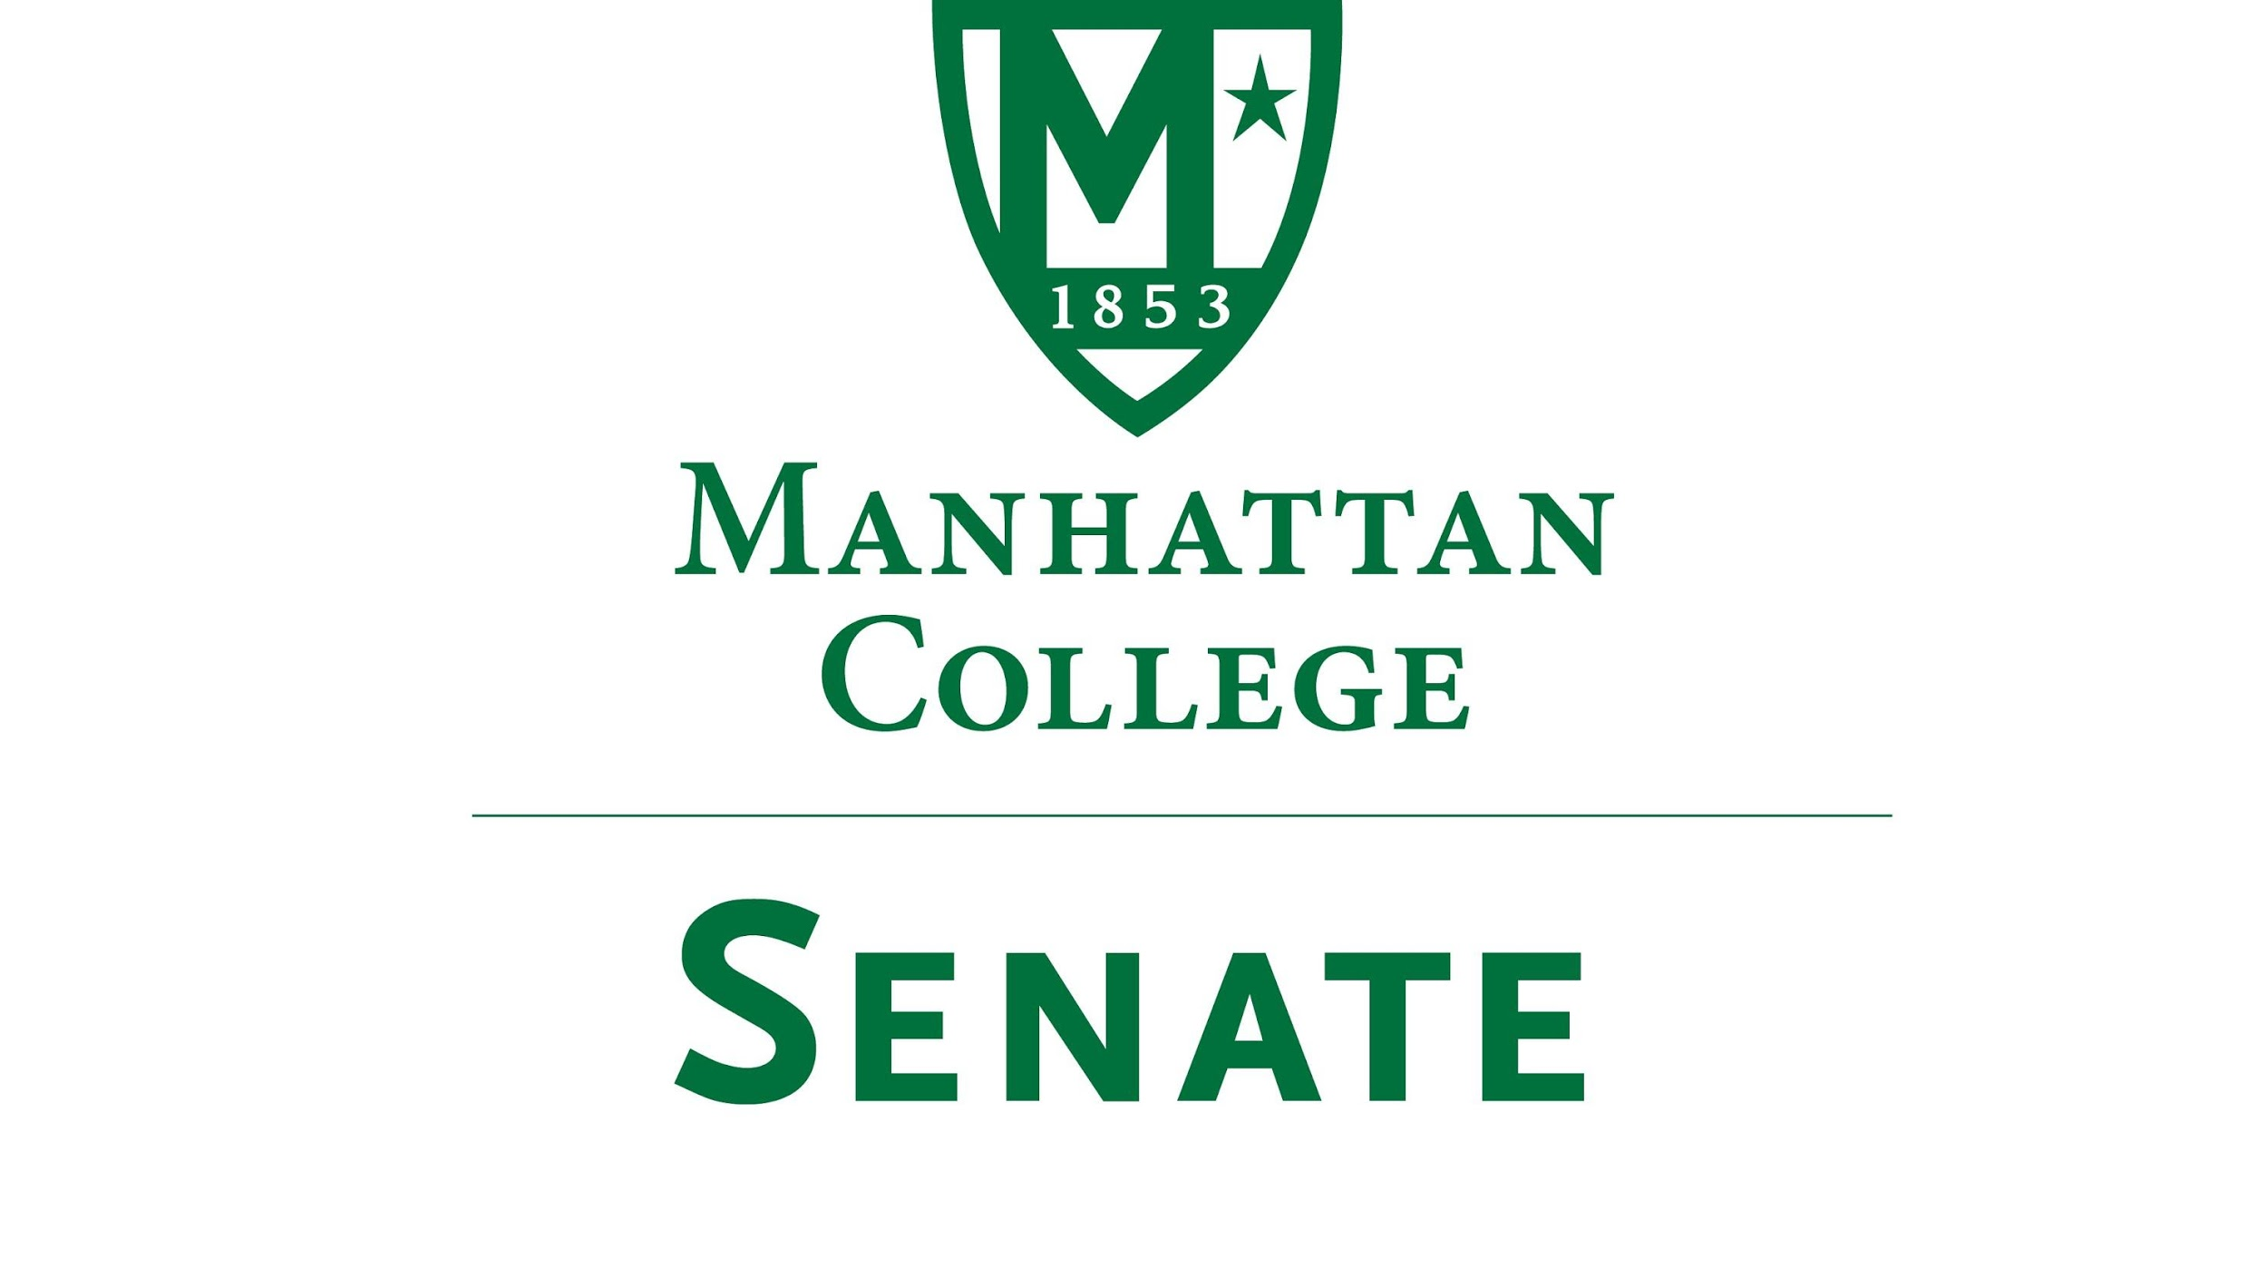

Tuesday, November 17th, 2020 | 3:30 pm | Google Meet
meet.google.com/xwp-mpit-epx

Livestream url : stream.meet.google.com/stream/851d9f53-c2cf-4071-b62a-72d95ba7deaf

Agenda
- Roll Call
- Approval of the Agenda
- Approval of Previous Minutes
- Reading from the “Green Book”
- Speaker’s Report
- Reports from the Standing Committees:
  - Educational Affairs Committee (EAC): Senator Schreiner
  - Campus Life Committee (CLC): Senator Ago
- Old Business
- New Business
  - Remarks on the College’s financial state:
    - Matthew McManness, VP of Finance
    - President O’Donnell
    - Provost Schreiner
  - Housing application process for Winter Intersession:
    - AJ Goodman, Assistant Director of Residence Life
- Adjourn

