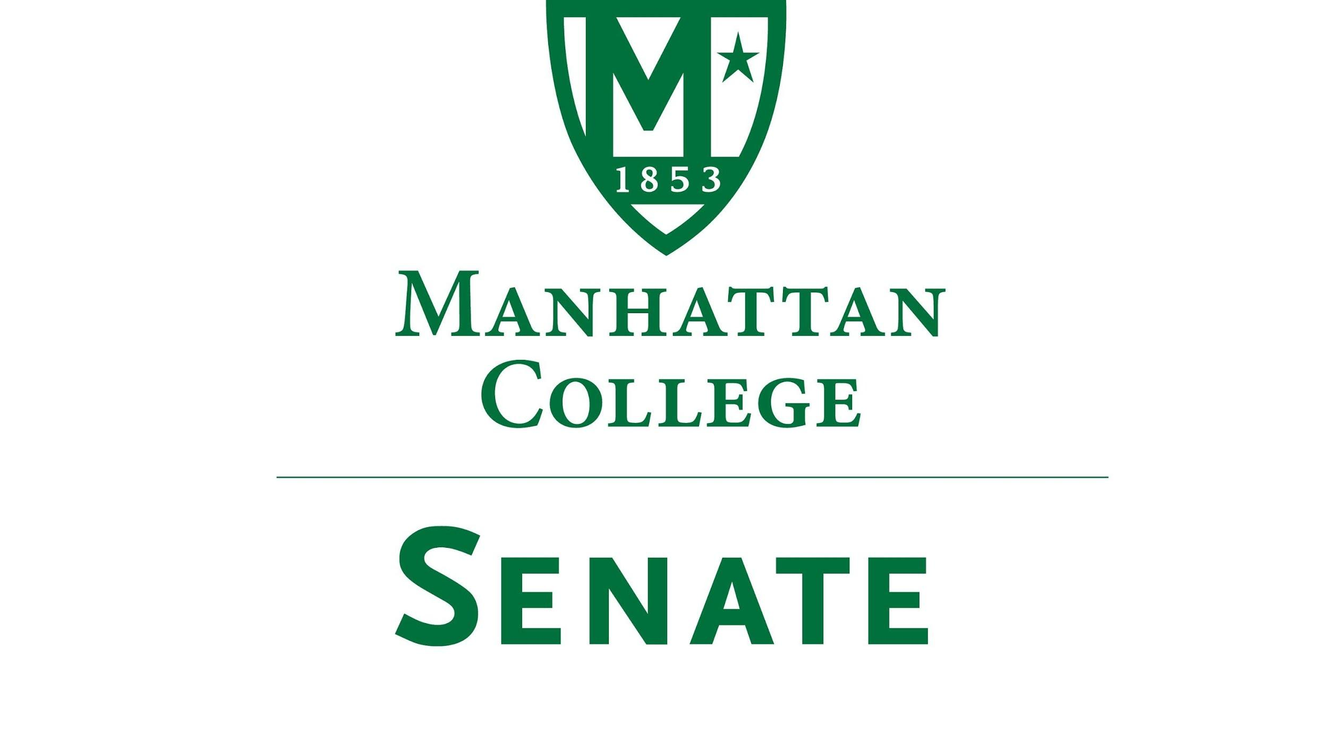

Tuesday, February 16th, 2021 | 3:30-5 pm |
Google Meet Link: meet.google.com/mod-xjeu-ivf
Livestream Link: https://stream.meet.google.com/stream/8c2e8b74-d791-44a2-97b5-f6002a69a765
Agenda
- Roll Call
- Approval of the Agenda
- Approval of Previous Minutes
- Reading from the “Green Book”
- Speaker’s Report
  - Anonymous questions for Matthew McManness, VP of Finance
  - Future Senate sponsored meeting regarding finance. Monday 2/22/21, 1 pm
- Reports from the Standing Committees:
  - Educational Affairs Committee (EAC): Senator Schreiner
  - Campus Life Committee (CLC): Senator Ago
- Old Business
- New Business
  - Remarks on Financial Aid and Student Employment:
    - Denise Scalzo, Director/ Financial Aid Administration
    - Werner Habermann, Assistant Director/Customer Service and Student Employment
  - Remarks on Residence Life and Student Housing:
    - Charles Clency, Director/ Residence Life
  - Remarks on Shared Governance
    - Provost Schreiner

- Adjourn

