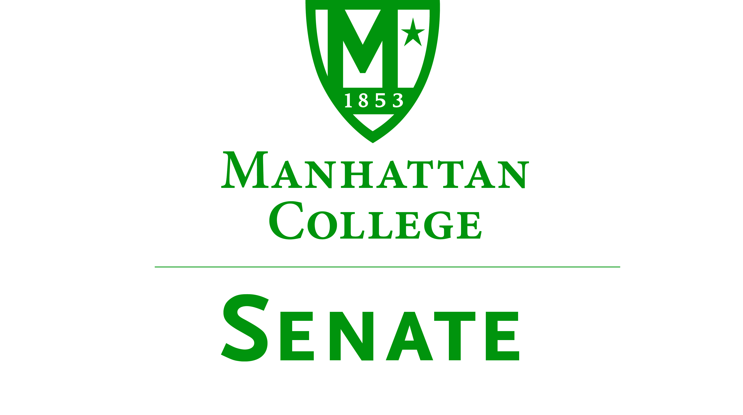
Tuesday, October 18, 2016 | 3:30pm | Kelly Commons 5A
Minutes
- Roll was taken.
  - Senators present: Sonny Ago, Salwa Ammar, Amira Annabi, Keith Brower, Shawna Bú Shell, Dana Coniglio, Antonio Cordoba, Amy Handfield, Nuwan Jayawickreme, Matthew Jura, Peter McCarthy, Michael McEneney, Margaret McKiernan, Joseph Moussa, Carolann O’Connor, Richard Saterlee, Francois-Xavier Thiolliere, Qian Wang, Jessica Wilson, Crystal Xu
  - Senators not present: Ankur Agrawal(excused), Micaela Bishop (excused), William Clyde(excused), Fionnuala Duffy, Kyle Meany, Lisamarie Nilaj, Kaitlyn Von Runnen(excused) Kevin Welsh
- Quorum was met.
- Meeting called to order by Speaker Jura at 3:40 PM
  - The Agenda for the September 20, 2016 meeting of the Senate was approved. Motion: To approve the agenda for the meeting on September 20, 2016 Discussion: No discussion.
  - Vote: Motion carried
  - Resolved: Agenda for meeting on September 20, 2016 was approved
- Speaker Jura read excerpt from p. 78 of the “Green Book.”
- Speakers report:
  - Senate Moodle page continually being enhanced
  - Entire community has access
  - Anonymous suggestion posting available
  - Follow senate twitter- mcsenate2015
  - Facebook page coming soon
- Presentation on Public Safety by Juan Cerezo, Director of Public Safety, and Pete DeCaro, Associate Director of Public Safety:
  - LEO Engineering Building: Doors modified for card access use; new signage installed, 2 new interior cameras installed on rear doors, New loading dock doors installed, Planning for new lobby receptionist desk, Planning for new lobby camera
  - Public Address System , 6 speakers installed – 2 on Kelly Commons; 4 on Memorial Hall, 2 system amplifiers in process of being installed , Work is in process to complete install and make required network connections
  - New Security Cameras: 2 cameras installed in OV lobby, 2 cameras installed in Jasper Lounge
- Presentation on the Study Abroad Program by Kevin Gschwend, Director of the Study Abroad Program:
    - Programs last approximately 6 days to 6 weeks, Taught on-site by MC professors, Some programs run every year, others in alternate years
    - Encourage faculty to design courses in countries we currently do not have programs.
- Reports from the Standing Committees
  - Educational Affairs Commission (EAC): Meeting Recapped by Senator Cordoba
- The new Chair of the CCC is Jennifer Edwards. The CCC approved the CWCC Learning Objectives over the summer. This year the committee will be examining the 24 credits shared by all schools. The EAC is supportive of faculty having off hours access to these buildings.
- CLC: The ID policy has changed. From 8 am to 10 pm you don’t need to swipe your ID. However, from 10 pm to 8 am you will need a Manhattan College ID to use the library. The library is proposing a literacy test (similar to the LOLT exam) to be taken by college seniors.
- Grad Council: Dean Ward gave a brief background of the Graduate Council. It consists of all the Deans, Directors of Graduate Programs, and the Provost. The committee meets on the first Wednesday of every month. In their meetings they discuss the following: admissions, marketing, advertising, increasing graduate enrollment (this year graduate enrollment grew by about 10%), as well as any other issues affecting the graduate students.
- There was then more discussion on dual enrollment courses and the following statement was resolved:
Credit for courses listed on a transcript from an accredited college or university but taught at a high school needs to be approved by the Dean of the School in which the student seeks to enroll.
  - Campus Life Committee: Meeting recapped by Senator Ago. The Campus Life Committee of the Manhattan College Senate met on October 3, 2016. The topic discussed was How to Better Serve the Manhattan College Commuter Students. Below are suggestions from the meeting:
    - Enhancing Commuter Services
    - More public printers in Kelly Commons
    - More public microwaves in Kelly Commons and Café 1853
    - Commuter student website centralizing all information about services and programs
    - Announcements under “Commuter Student” section on college website
    - Commuter student email listserve: commuter@manhattan.edu (established)
    - Designating game room as commuter student meeting room/lounge with working TVs, couches, etc.
    - Discounted parking rates for commuter students
    - Discounted meal plan “per swipe” for commuter students
    - Establish a commuter student support group
    - Shuttle bus/van service to East Bronx
- Old Business. No old business.
- New Business. No new business
- Adjourned at 4:33 PM
Respectfully submitted by S. BuShell

