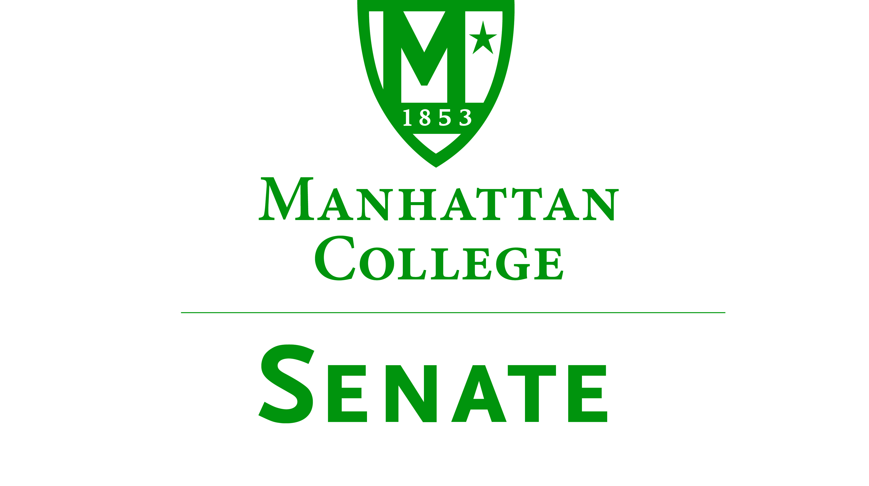
Tuesday, November 15, 2016 | 3:30pm | Kelly Commons 5B
Minutes
- Roll was taken.
  - Senators present: Sonny Ago, Amira Annabi, Micaela Bishop, Keith Brower, Antonio Cordoba, Amy Handfield, Matthew Jura, Peter McCarthy, Michael McEneney, Margaret McKiernan, Joseph Moussa, Lisamarie Nilaj, Richard Satterlee, Kaitlyn von Runnen, Kevin Welsh, Jessica Wilson
  - Senators not present: Ankur Agrawal (excused), Salwa Ammar (excused), Shawna BuShell (excused), William Clyde, Dana Coniglio (excused), Fionnuala Duffy, Nuwan Jayawickreme (excused), Kyle Meany, Carolann O’Connor (excused), Francois-Xavier Thiolliere, Qian Wang (excused), Crystal Xu
- Quorum was met.
- Meeting called to order by Speaker Jura at 3:39pm.
- Approval of the Agenda for the November 15, 2016 meeting of the Senate.
Motion: To approve the agenda for the meeting of November 15, 2016.
Discussion: No Discussion
  - Vote: Motion carried
  - Resolved: Agenda for meeting on November 15, 2016 was approved.
- Approval of the Minutes of the October 18, 2016 meeting of the Senate.
Motion: To approve the Minutes for the meeting on October 18, 2016.
Discussion: No Discussion
  - Vote: Motion carried
  - Resolved: Minutes for meeting on October 18, 2016 were approved.
- Speaker Jura read excerpt from p. 14 of the “Green Book.”
- Speaker’s Report, Speaker Jura:
  - Thanked Dr. Hannigan and Brother Jack Curran for attending.
  - Senate Facebook page is up and running.
  - Cross walk between Leo and RLC buildings
  - Undergraduate Commencement Date 2017
- Presentation on the Counseling Center by Dr. Terence Hannigan, Director of the Counseling Center:
  - Counseling Center’s location is on the fifth floor of Miguel Hall, offering convenience and privacy. The hours of operation are Monday through Friday from 9am-4:30pm
  - The staffing of the Counseling Center consists of three clinicians, one full time secretary, one part time counselor and one psychiatric clinician (on Tuesdays). This is an advancement from 2011, in which there were only two clinicians, one part time secretary, and one part time counselor.
  - The Counseling Center is responsible for referrals, working with public safety, consultations, scheduling consultations, and walk-in hours (Monday, Wednesday, Friday 2-3pm).
  - The Counseling Center has a QPR (Suicide Prevention Training) and Alcohol-Wise training program established on campus.
  - Counselors are on call for emergencies every night.
  - Since 2011, the Counseling Center has experienced a tremendous growth in the number of students who utilize the center due to an increase in the Student Body. In 2011, 267 students accessed the Counseling Center. In 2015, 573 students accessed the Counseling Center. As enrollment has increased by 28.6%, the number of hours for availability of appointments has increased by 11%.
  - At the conclusion of the presentation, Senator Satterlee added that Dr. Hannigan will be retiring at the conclusion of this semester. There has been a committee formed with Dr. Ladda, Senator McCarthy, Senator Jayawickreme, Diana Cruz, Ryan Bunts, Dean Carey, and himself, in search of a replacement. The finalists will be on campus this week. Lastly, Senator Satterlee mentioned that in addition to a new director of the Counseling Center, a third clinician will be added.
- Presentation on Mission, Strategic Plan and Core Identity by Brother Jack Curran
  - Mission Statement
  - Strategic Plan: Internationally and at Manhattan College: The DENA and Manhattan College standards for the strategic plan align. The DENA team at Manhattan College consists of Gwendolyn Tedeschi, Lois Harr, Senator Ammar, President O’Donnell, and Brother Jack Curran.
  - Lasallian Core Principles are celebrated as well as the Lasallian hallmarks during Mission Month in April.
  - Coming Soon: Racial Justice: Inclusivity, Diversity, and Mission Compatibility.
- Reports from Standing Committees
  - Educational Affairs Commission (EAC): Meeting recapped by Senator Cordoba.
    - The CCC, led by Jennifer Edwards, approved the Environmental Science program.
    - Accessibility to Leo through the ID policy has taken place.
    - Brother Michael Shubnell has been working on advocating for the referral system of MapWorks.
    - Course Evaluations will begin December 1st and conclude on December 9th. Independent studies and internships will not be included due to privacy.
    - Study Aboard and Lasallian Experience Fund: Proposed $250 fee to encourage students to get involved in this opportunity.
  - Campus Life Commission (CLC): No new business
- Old Business. No old business.
- New Business
  - Cross Walk between RLC and Leo Buildings
    - Cars are speeding and last month a student was struck by a car. The student was treated for a leg injury the next day. Senator Satterlee reported that a cross walk has been asked for, but the City of New York is hesitant about establishing one. Senator Satterlee asks for community support, mostly students to hopefully get one. Hopefully, the Senate will pass a motion next meeting.
  - Commencement Date
    - Set for Friday May 19, 2016. Hopefully, next meeting the Senate will receive a report from Senator Clyde on the rationale behind the date change from Sunday to a Friday.
- Adjourned at 5:03pm.

Respectfully submitted by Kaitlyn von Runnen

