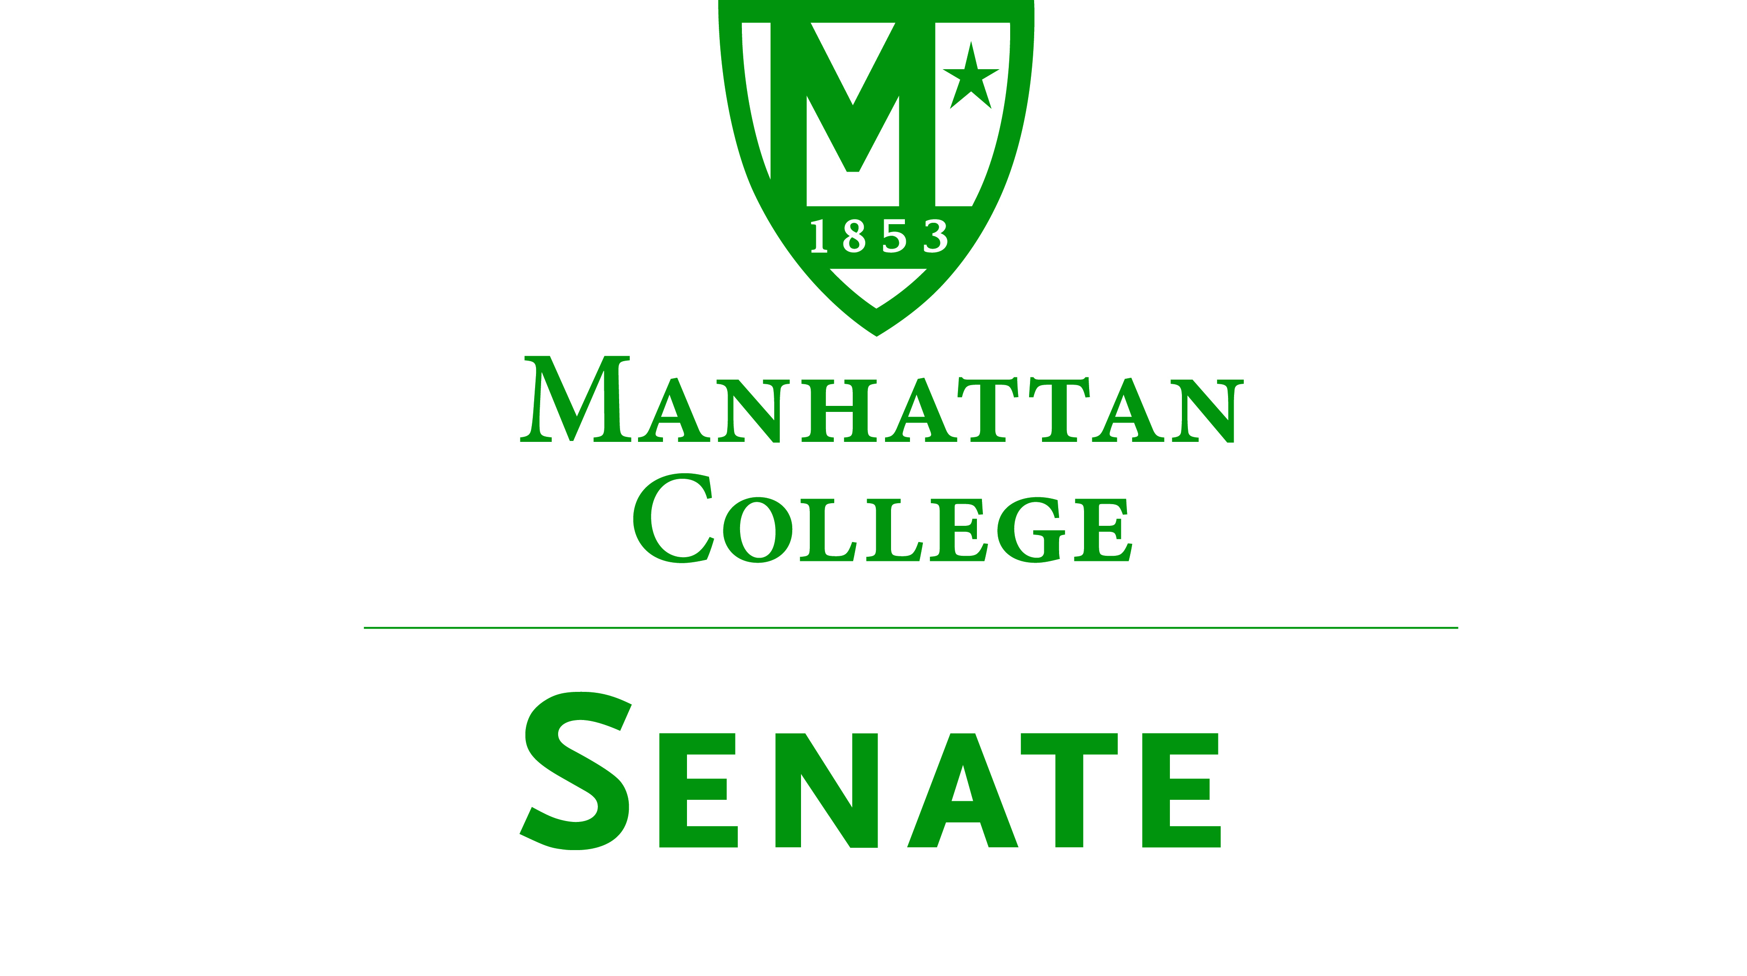
Tuesday, February 21, 2017 | 3:30pm | Kelly Commons 5A

Minutes
- Roll was taken.
  - Senators present: Amira Annabi, Ankur Agrawal, Micaela Bishop, Keith Brower, Shawna BuShell, Dana Coniglio, Antonio Cordoba, Nuwan Jayawickreme, Matthew Jura, Peter McCarthy, Michael McEneney, Margaret McKiernan, Lisamarie Nilaj, Carolann O’Connor, Kaitlyn von Runnen, Jessica Wilson, Qian Wang, Crystal Xu
  - Senators not present: Sonny Ago(excused), Salwa Ammar (excused), William Clyde(excused), Fionnuala Duffy, Amy Handfield, Kyle Meany, Joseph Moussa(excused), Richard Satterlee(excused), Francois-Xavier Thiolliere, Kevin Welsh
- Quorum was met.
- Meeting called to order by Speaker Jura at 3:35pm.
- Approval of the Agenda
  - Motion passed
- Approval of Previous Minutes
  - Motion passed
- Reading from the “Green Book” pg.32
- Fire Drill
- Speaker’s Report, Speaker Jura:
  - Growing concern for safety crossing the street between Leo Bldgs and the RLC
  - Motion to craft a statement from senate to administration to look into issue with the city to place a crosswalk, speed bumps or other safety precautions for our students
- Presentation on the Middle States Periodic Review Report (PRR), Dean Brower
  - Dean Brower presented on the Middle States progress.
  - The Middle States website was viewed [http://www.msche.org/].
  - All faculty and staff were encouraged to participate in the Report on Google Doc [https://drive.google.com/drive/folders/0B58P797HMtP3WDI4NDhjM0xDV0k].

- Presentation from the Radiation Therapy Technology & Radiologic Technology Programs, Kayla Valentino, Coordinator and Ken Martinucci, Coordinator
  - Kayla Valentino went over the three programs they offer: Radiation Therapy Technology (RTT), Radio Technology – X-Ray (RTX), and Nuclear Medicine Technology (NMT).
  - Students in the program have an intensive clinical internships and take note of the hospitals that we have are students:
- Radiation Therapy Technology:
- AROS of Rockland
- Bensonhurst Radiation Oncology
- Beth Israel Medical Center
- East Side Radiation
- Flushing Radiation Oncology
- Montefiore Medical Center
- Mount Sinai Medical Center
- New York Presbyterian –Columbia Hospital
- NYP – Lower Manhattan Cancer Center
- New York Radiation Associates
- Queens Hospital Center
- Tribeca Radiation Oncology
- Westchester Medical Center
- Radiologic Technology:
- New York Presbyterian Cornell-
- Weill Medical Center
- Hospital for Special Surgery
- Memorial Sloan Kettering
  - Students who graduate from the program attain these careers:
Radiation Therapy Technology: | Radiologic Technology:
- Staff radiation therapist | - Mammographers
- Dosimetrist | - CAT Scan Technologists
- Hospital administrator | - MRI Technologists
- Industry sales representative | - Cardiac Interventional Tech.
- Research and Development technologist | - Vascular Interventional Tech.
- Technology program educator | - Managers & Administrators
- Salary – 60,000-80,000/year starting | - Salary-50,000-60,000/year

- Reports from the Standing Committees:
Educational Affairs Committee:
  - Senator Cordoba reviewed the digital EAC minutes that will be posted in Moodle
  - Much of the meeting concerned the Academic Calendar

Campus Life Committee: (Submitted Electronically)
Student Life Division:
- Mini Commuter Student Appreciation- This event was held on December 7th 2017. It had free coffee and snacks to those in attendance and we offered many prizes for the students. The prizes included metro cards, gas cards, travel mugs, travel bags, t-shirts, and cellphone ID holders.
- Commuter Student Meet and Greet- This event was held in accordance with the Student Life Administrators on Thursday, February 16th. This was a great opportunity for the administration to gain an understanding of the commuter population’s needs and experiences. Over 30 students RSVP’d to this event and the majority of attendees are active members of the Commuter Student Committee.
- Community Luncheon- This event was hosted by the Student Neighborhood Relations Committee and co-hosted by the Dean of Students & Student Government. The goal of this event was to have students and faculty connect with members of the community to talk about concerns regarding students that live off campus.
- The Diversity Center has been consistently hosting dissections about the presidential elections and the executive order in the Multicultural center.
- Old Business
  - Discussion on Graduation date (Tabled)
- New Business
  - Discussion on Academic Schedule (Tabled)
- Adjourn at 5:01pm.

