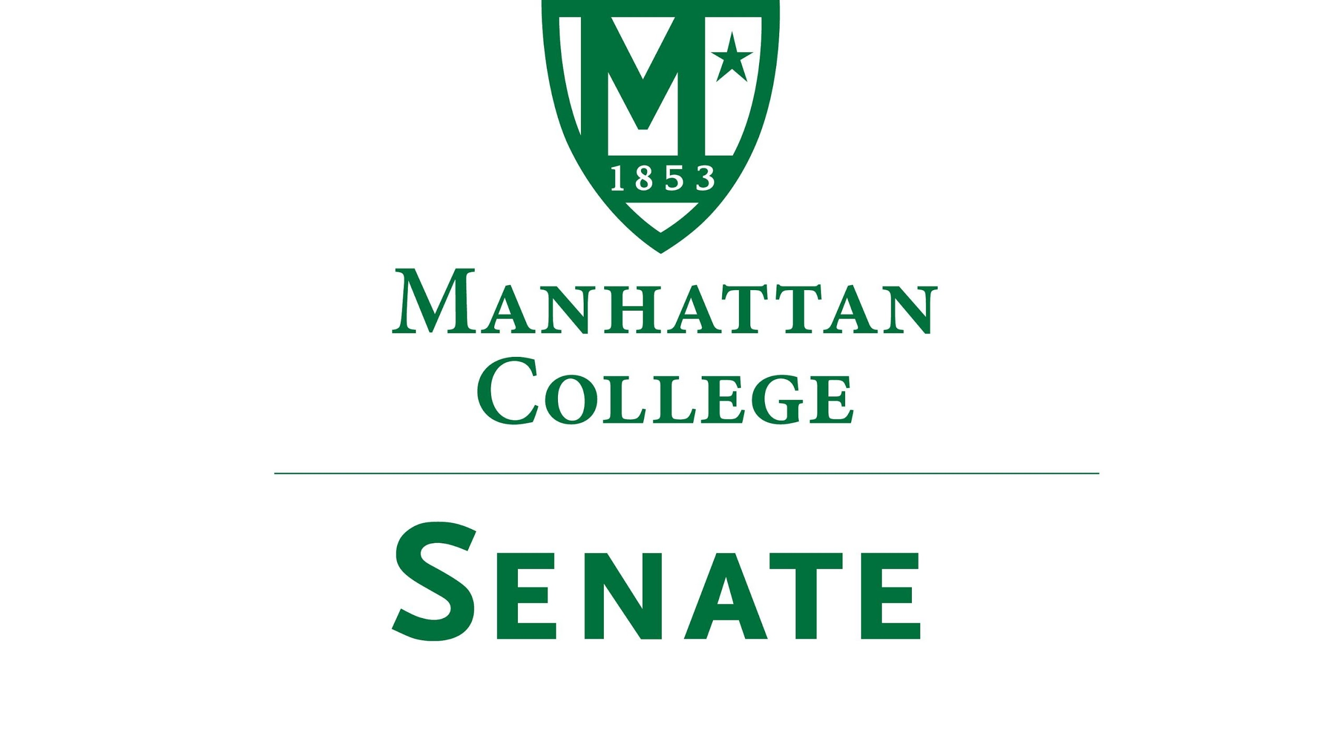
Tuesday, September 19, 2017 | 3:30pm | Kelly Commons 5A

Minutes
Roll Call
- Roll was Taken
- Senators Present: Richard Saterlee, Sonny Ago, Janet Rovenpor, Keith Brower, William Clyde, Michael McEneney, Nuwan Jayawickreme, Amira Annabi, Crystal Xu, Shawna BuShell, Jessica Wilson, Daniel Hochstein, Amy Handfield, Ankur Agrawal, Lawrence Udeigwe, Margaret McKiernan, Carolann O'Connor, Kaitlyn Von Runnen, Lisamarie Nilaj, Isabel Quinones, Chris Cacciavillani, Ryan Quattromani, Dominika Wrozynski
- Senators Not Present: Joseph Moussa, Jenna Zawislak, Timothy Gress (excused), Michael Szczech, Tim Ward (excused)
- Approval of the Agenda
- Passed
- Approval of Previous Minutes
- Passed
- Reading from the “Green Book” pg. 38
- Presentation by President Brennan O’Donnell
- President O’Donnell spoke on Manhattan College moving forward to report out regularly to report out regularly to our community. He highlighted the publications “Focus on Faculty” and the President’s report.
- Current Enrollment 3459
- Transfer students currently very strong-- uncertainty with economy-- students are going to JC first.
- Most diverse class Manhattan College has ever welcomed.
- ALANA Categories-- 25% latino/a, 35% First generation college students
- Do we need a lower Manhattan location?
- Remarks by Dr. Richard Satterlee, Vice President for Student Life, on the impact of the rescinding of DACA on Manhattan College students.
- “As you know, our Lasallian Catholic mission calls us to support all of the students "entrusted to our care," regardless of their immigration status, citizenship or nationality.” We want to make faculty, staff and students aware that a new FAQ titled "Resources for DACA Students" is available on our website at:
- https://www.manhattan.edu/daca
This document will be updated regularly and is meant to keep the community up to date on the latest information about DACA and possible legislative action.
- Speaker’s Report
- Thank you to Matthew Jura for his commitment to the Senate. As the new speaker, I am hoping to encourage to connect with their constituents, and increase visibility of senate activities.
- Reports from the Standing Committees
  - Educational Affairs Commission (EAC): Senator Clyde reported that all Minutes will have red highlighted action items so that issues can be readily seen.
  - Campus Life Committee: Welcomes Marilyn Carter-Stevens with as Director of Commuter Services and Outreach focusing on commuter student affairs.
- Old Business
- None
- New Business
  - Proposal by Dr. Robert Geraci (Religious Studies) to substitute the Columbus Day holiday with a holiday on Election Day
i. Discussion and tabled.
b. Next Senate Meeting will be on October 17, 2017. Note: Will be hosted in the O’Malley library.
- Adjourn

