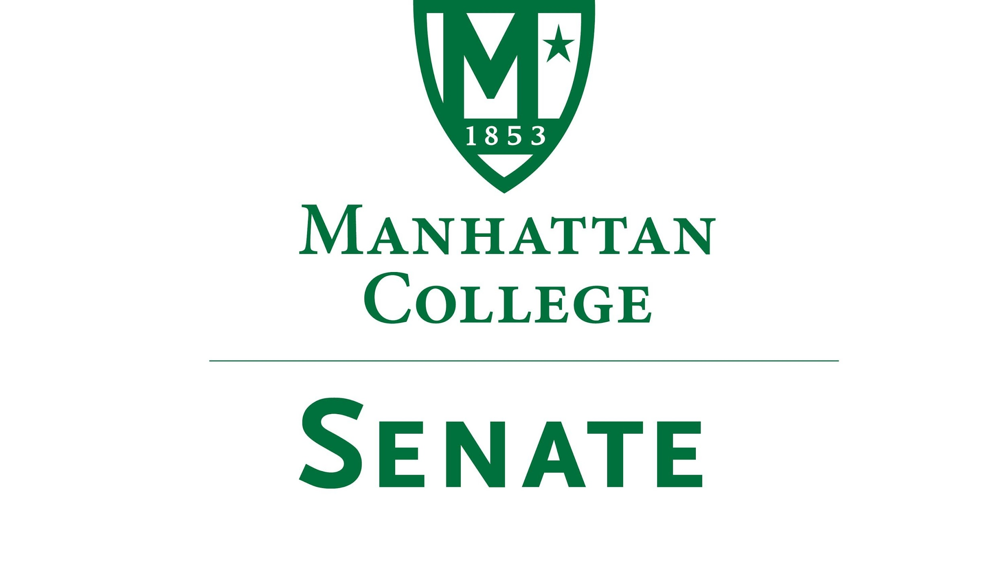
Tuesday, October 17th 2017 | 3:35pm | O’Malley Library Room 100 (Alumni Room)

Minutes
- Roll Call
- Senators Present: Richard Saterlee, Sonny Ago, Janet Rovenpor, Keith Brower, William Clyde, Michael McEneney, Nuwan Jayawickreme, Amira Annabi, Crystal Xu, Shawna BuShell, Jessica Wilson, Daniel Hochstein, Amy Handfield, Lawrence Udeigwe, Margaret McKiernan, William Merriman, Carolann O'Connor, Kaitlyn Von Runnen, Isabel Quinones, Ryan Quattromani, Dominika Wrozynski, Michael Szczech, Jenna Zawislak
- Senators Not Present: Joseph Moussa, Timothy Gress(excused), Lisamarie Nilaj, Chris Cacciavillani(excused), Ankur Agrawal(excused)
- Approval of the Agenda
- Passed
- Approval of Previous Minutes
- Passed
- Reading from the Green Book pg. 46
- Archbishop Desmond Tutu: “Let us be united, let us be filled with hope, let us be those who respect one another.”
- Presentation by Provost/Senator Dr. William Clyde on High Impact Practices (HIPs)
- HIPs have been proven to increase graduation rates. Manhattan College is proposing to require three HIPs for all undergraduates. These include service learning or study abroad, research or internship opportunity, and Capstone. The deans of the schools are also working on a fourth, which is a First Year Experience Program.
- Speaker’s Report
- Please refer to Senate Moodle Page to find all documents.
- Remember John LaSallian 5 principles: Faith in the Presence of God, Concern for the Poor and Social Justice, Respect for All Persons, Quality Education, Inclusive Community.
- Reports from the Standing Committees
  - Educational Affairs Commission (EAC)
Provost Clyde Reported:
Tamara Britt our new General Council was introduced:
Ms. Britt is the first individual general counsel. Ms. Britt comes from Rutgers University. Ms. Britt stated that her role is to be preventive, proactive and interactive. She works on contracts, litigations and policies. One of her main goals is to work on governmental relations on the local, state and federal levels to heighten Manhattan College’s status. Her office is located in Miguel 100.
Midterm Grade Policy
Provost Clyde sent faculty the catalog language, in which the policy states that midterm grades must be issued for all Manhattan College students not just those students with a D or F.
See EAC full Meeting Report in Moodle.

  - Campus Life Committee
Senator Ago Reported:
People are still encouraged to join, especially students.
New policy requiring registration and license. Why is there a new policy in place? Why was there no prior notification of this policy? How is the registration and license information being stored in regards to privacy and the potential for identity theft, particularly, in light of Equifax?

Parking Garage: Growing concern over the lack of available parking spaces. For example, the 1st and 2nd level parking is currently being occupied by the Manhattan College Physical Plant Department, taking a number of parking spaces off-line.

ID Access: Needs to be clearly identified in regards to commuter students visiting hours in the residence halls. The hours of operation for certain buildings and classroom labs in Leo need to be expanded for students to do research.

Concern over student wages on campus was discussed, specifically, exactly what is the minimum wage? Should there be differing wages for specific jobs like research assistants? And, should wages be increased based on the number years of employment? This information should be clearly outlined on the Manhattan College website.

See full Campus Life Committee Report in Moodle.
8. Continued discussion of proposal by Dr. Robert Geraci (Religious Studies) to substitute the Columbus Day holiday. Dr. Adam Aronson (History Department) gave a talk on the history of Columbus and the holiday’s formation. (See full set of documents on the topic in Moodle) Much discussion on the distinction between the day off for scheduling reasons versus social justice reasons. Discussion on Senate’s role in the discussions of changing the day on the calendar. Consensus that Senate's role is to recommend to the administration all resolutions voted upon in Senate Meetings. Discussion tabled.
9. New Business
  - None
10. Adjourned at 5:05 pm

