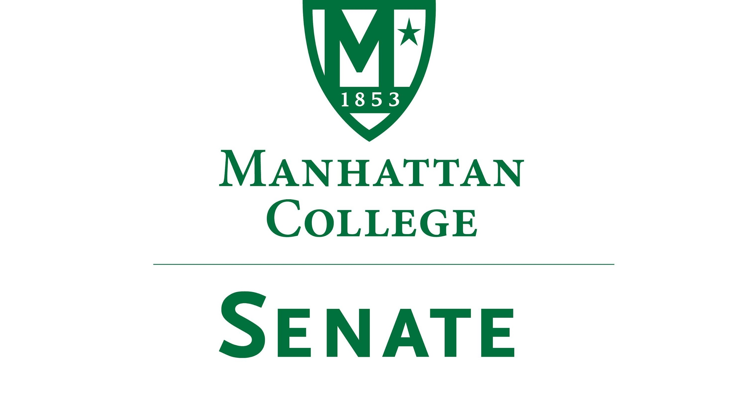
Tuesday, November 21, 2017 20th 2018 | 3:30pm | Kelly Commons Room 5A

Minutes
- Roll Call
- Senators Present: Richard Saterlee, Sonny Ago, Tim Ward, William Clyde, Nuwan Jayawickreme, Shawna BuShell, Jessica Wilson, Daniel Hochstein, Amy Handfield, Lawrence Udeigwe, Margaret McKiernan, William Merriman, Carolann O'Connor, Kaitlyn Von Runnen, Ryan Quattromani, Dominika Wrozynski, Michael Szczech, Jenna Zawislak, Tim Ward
- Senators Not Present: Keith Brower(excused), Michael McEneney(excused), Amira Annabi, Crystal Xu, Joseph Moussa, Isabel Quinones, Timothy Gress, Lisamarie Nilaj, Chris Cacciavillani, Ankur Agrawal
- Approval of the Agenda
- Passed
- Approval of Previous Minutes
- Passed with Corrections
- Reading from the Green Book pg. 104
- Presentation on New Library Resources by Amy Handfield, Assistant Director, Access Services, O’Malley Library
- Please see updated library websites: https://lib.manhattan.edu/home. It has many new resources. If you have any questions contact: Amy Handfield: amy.handfield@manhattan.edu
- Speaker’s Report
- For next Spring’s Agenda, if you have any ideas let us know by December 15th.
- There will be three regular meetings and one election meeting May 2nd at noon.
- There were errors regarding the senate in the faculty handbook. Shawn Ladda is working on the errors regarding the Senate. Our constitution is correct, and faculty handbook will be updated.
- Reports from the Standing Committees
  - Educational Affairs Commission (EAC)
Report by Senator Clyde:
Midterm grades should be good indicators for students. Committee continuing to discuss.
See Draft Report in Moodle.

  - Campus Life Committee
Discussion on Columbus Day Survey issue returned to table.
- Old Business
- None
- New Business
  - Discussion of proposal submitted by Senator Udeigwe concerning access to south campus after hours
Much discussion. Many of the issues fall under public safety which Senator Saterlee to report back next meeting.
  - Discussion of proposal submitted by Senator Quattromani concerning hourly wages of student workers
Much discussion. Resolution proposed by Senator Tim Ward
Voted on and passed.
See full proposal in Moodle.
- Adjourn at 5:12 pm

