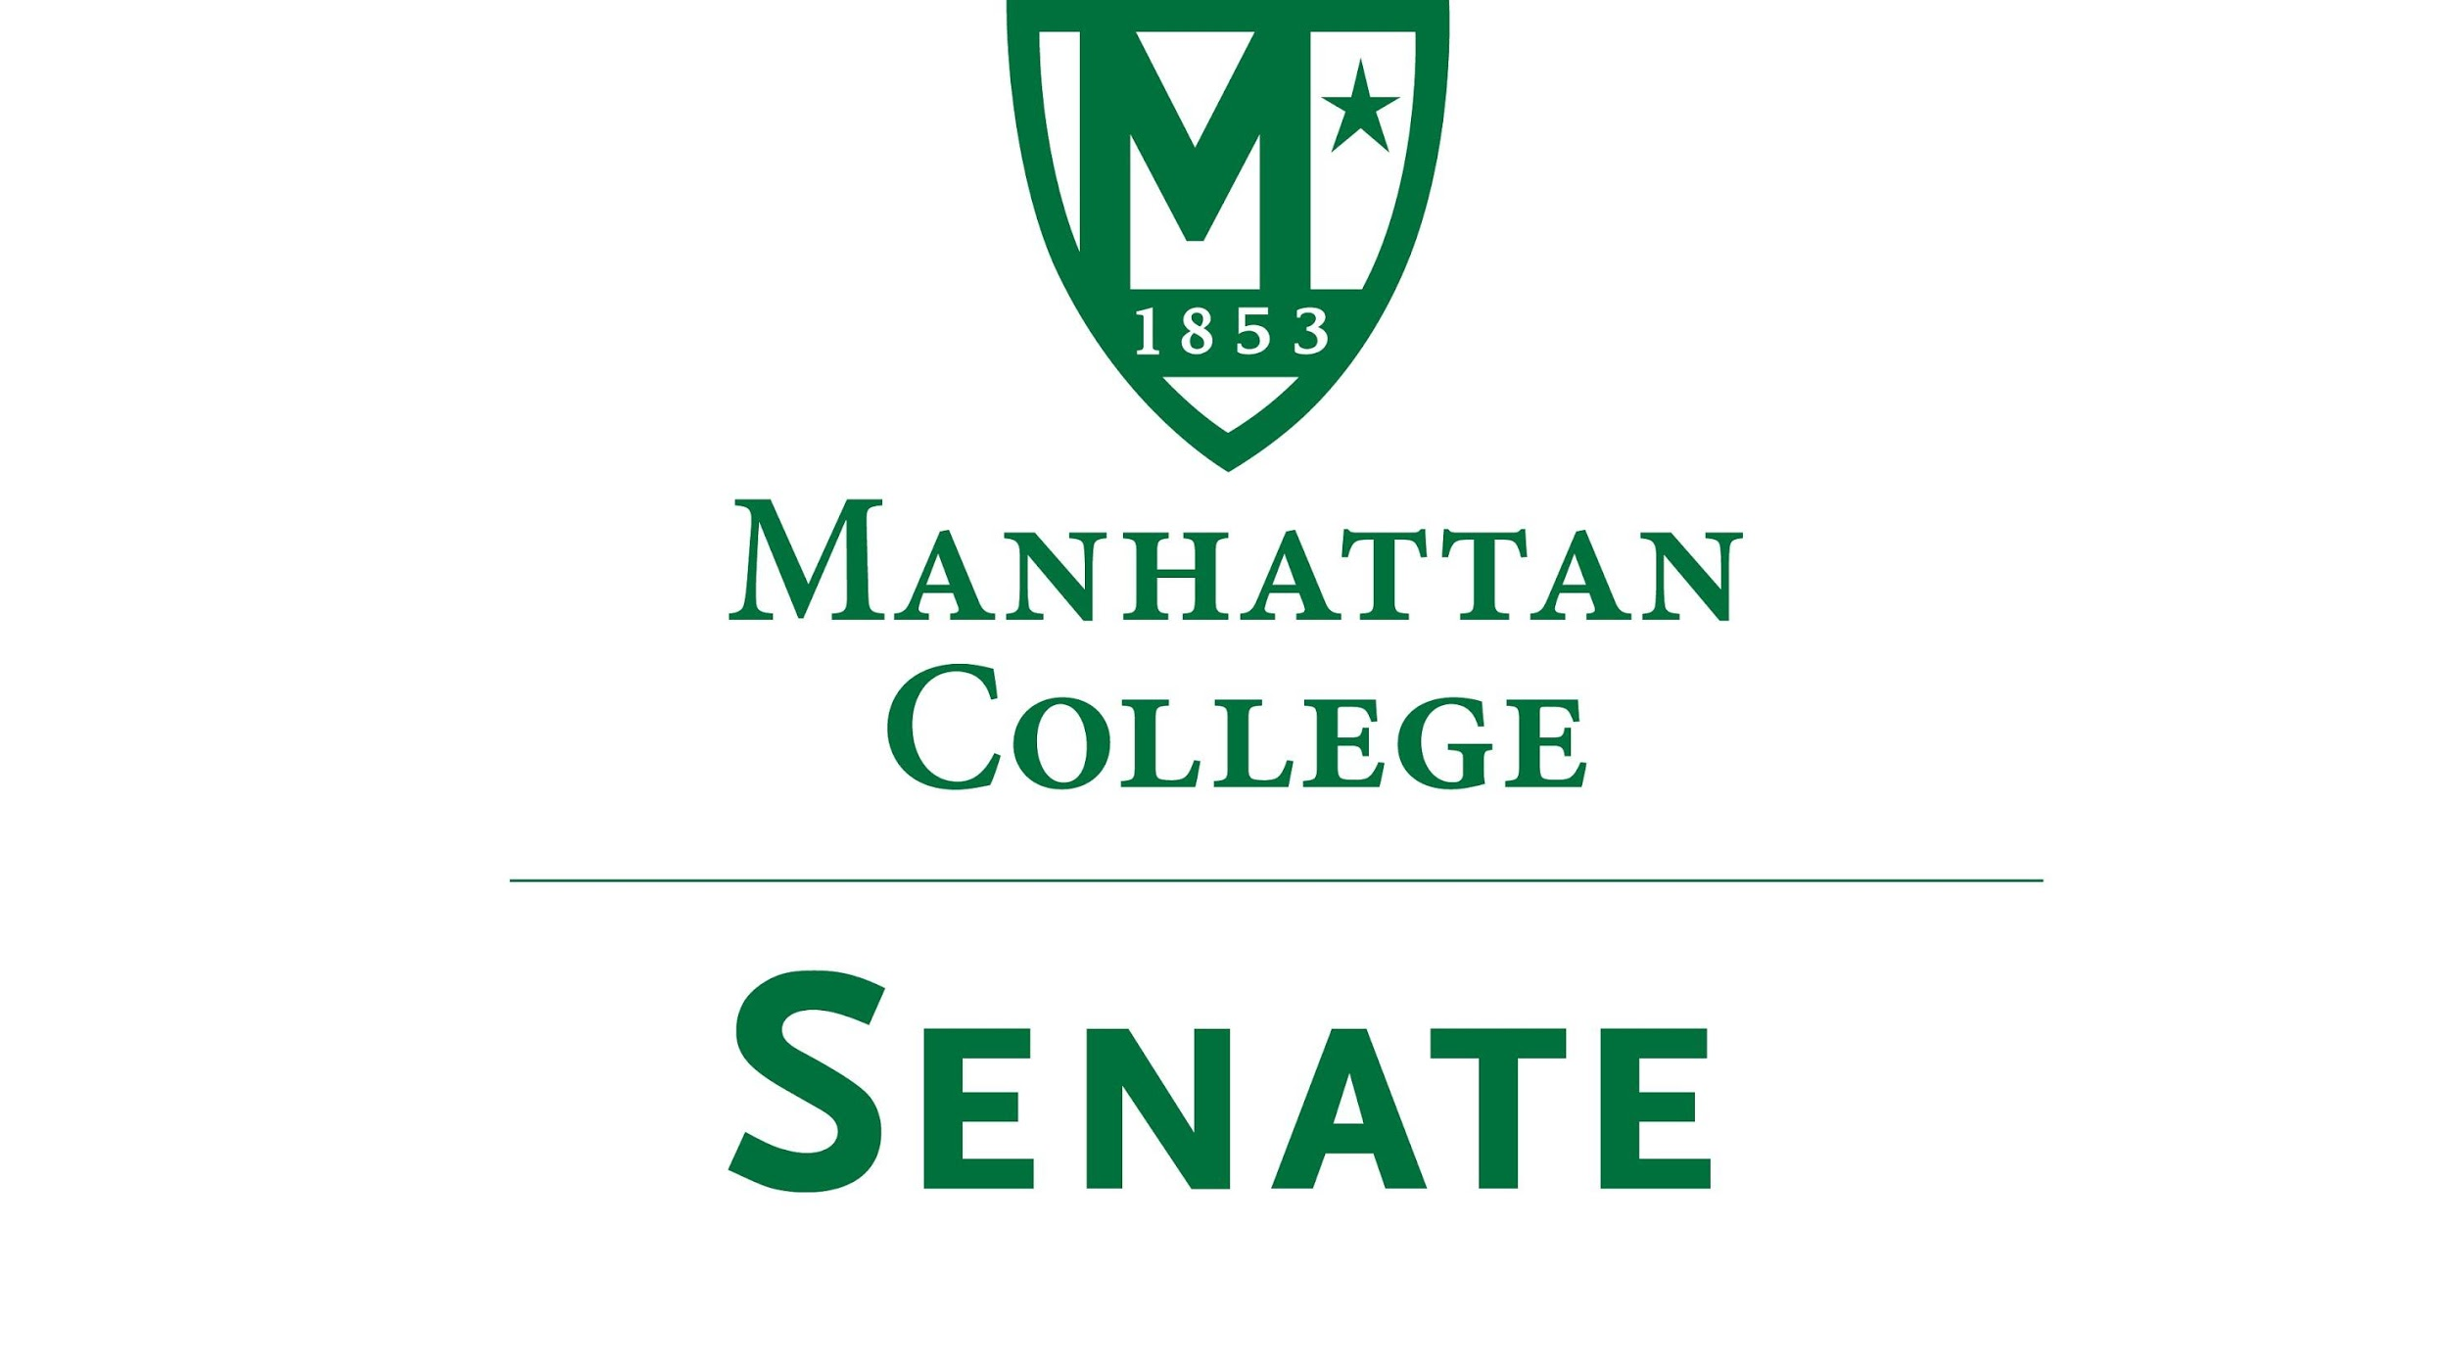
Tuesday, February 20th, 2018 | 3:30 pm | Kelly Commons Room 5C

Draft Minutes
- Roll Call
- Senators Present: Sonny Ago, Tim Ward, Keith Brower, William Clyde, Michael McEneney, Dominika Wrozynski, Nuwan Jayawickreme, Amira Annabi, Crystal Xu, Shawna BuShell, William Merriman, Jessica Wilson, Daniel Hochstein, Amy Handfield, Ankur Agrawal, Lawrence Udeigwe, Margaret McKiernan, Carolann O'Connor, Kaitlyn Von Runnen, Isabel Quinones, , Timothy Gress,
- Senators Not Present: Richard Saterlee, Joseph Moussa, Lisamarie Nilaj, Chris Cacciavillani, Jenna Zawislak, Ryan Quattromani (excused), Michael Szczech,(excused)
- Approval of the Agenda
- Passed
- Approval of Previous Minutes
- Passed with Corrections
- Reading from the Green Book Pg. 38
- Presentation on Mission Month by Brother Jack Curran, Vice President of Mission
  - Discussed the growth of Mission Month and the great strides that have been made to unite events within a common calendar: See Moodle for Handout
- Presentation on Strategies to Reduce Paper Usage and Copying Costs by Dr. Shawna Bu Shell, Assistant Professor of Education
  - Discussed her department’s activities to reduce copier use. Suggestions:
    - Update copier codes each year
    - Encourage use of Moodle for a syllabi and class handouts
    - Give Faculty quarterly feedback on their copier totals and suggestions for alternatives in departmental meetings
- Speaker’s Report
  - A condensed version of Roberts Rules posted in Moodle to help guide us in the meeting processes
  - Need a volunteer to be a liaison for the trustee meeting June 18
- Reports from the Standing Committees
  - Educational Affairs Commission (EAC)
    - Report by Senator Clyde: “no big action items” (See Minutes in Moodle)
  - Campus Life Committee
    - Report by Senator Ago: Concerns on public safety regarding active shooter training. Working with NYPD to offer a refresher course later in this semester. We need to revisit the flow of communication for emergency and incidents to improve on “question mark” incidents (example given of car accident lower ramp are of Kelly that left the sidewalk rails with noticeable damage but no communication on what happened in the area to the MC Community)

- Old Business
  - Update on the issue regarding lack of faculty access to south campus after hours:
    - Monday through Friday when classes are in session-Entry door on Corlear Avenue unbolted at 6:00 AM and then on card access until 11:30 PM after which card access is suspended. The door will be bolted at 11:30 PM. Alarms on from midnight until 6:00 AM.
    - Saturday – Card access on Corlear door from 7:00 AM until 5:00 PM. Access for designated faculty and staff cards until 11:30 PM. Students will also be allowed access between 5:00 PM and 11:30 PM when accompanied by faculty or staff. Alarms set by 10:00 pm. Designated faculty and staff will be determined and approved by appropriate deans and directors (This will need further clarification)
    - Sunday and other school holidays. Access will be for faculty and staff between 7 AM and 11:30 PM. Students will be allowed access when accompanied by faculty or staff
  - Continued discussion of whether the college should continue commemorating Columbus Day
    - Resolution from the Campus Life Committee that Columbus Day will now be referred to as Autumn/Fall Break, keeping that day free for students.
    - Voted on and Passed with 17 yes 1 Abstention

- New Business
  - None
- Adjourn at 4:30 pm

