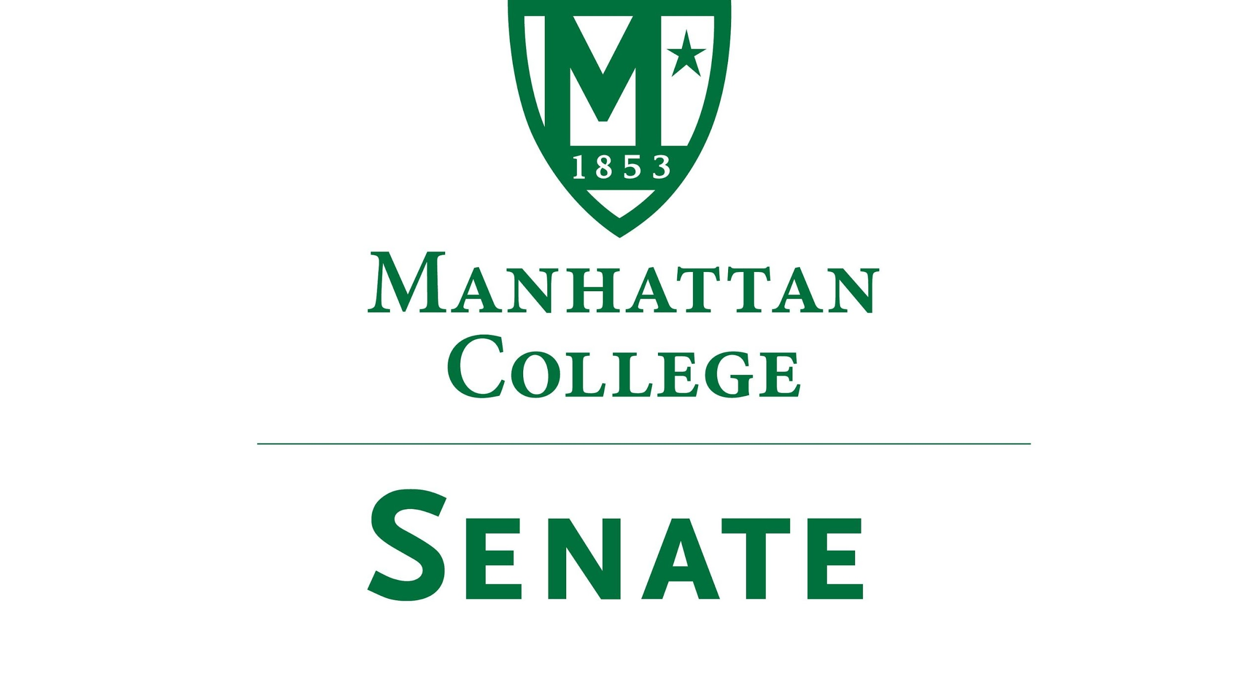
Tuesday, April 17th 2017 | 3:37pm | Kelly Commons Room 5A
Draft
Minutes
- Roll Call: Quorum Met
- Senators Present: Richard Satterlee, Sonny Ago, Tim Ward, Nuwan Jayawickreme, Shawna BuShell, Jessica Wilson, Daniel Hochstein, Amy Handfield, Lawrence Udeigwe, Margaret McKiernan, Timothy Gress, Joseph Moussa, Lisamarie Nilaj, Ankur Agrawal, William Merriman, Crystal Xu, Ryan Quattromani, Dominika Wrozynski
- Senators Not Present: Keith Brower(excused), Michael Szczech, William Clyde(excused), Michael McEneney(excused), Amira Annabi, Kaitlyn Von Runnen(excused), Carolann O'Connor(excused), Isabel Quinones(excused), Jenna Zawislak, Chris Cacciavillani
- Approval of the Agenda
- Passed
- Approval of Previous Minutes
- Passed with grammatical corrections
- Reading from the Green Book pg. 96 St. John De LaSalle
- Strategic Planning Update, President Brennan O’Donnell
  - “Thank you to everyone who does the important work with our students especially today on Accepted Students Day”. Yield from Acceptance Students Day over 50% from those who come to campus.
  - Taskstream has made it easy to see each other's goals in line with the strategic plan and draw on the expertise of the community. The projects and ideas set forth in this community have been spectacular
- Presentation on Non-Credit Programs at the School of Continuing and Professional Studies, Edgar Zavala, Director of Non-Credit Programs, School of Continuing Professional Studies.
  - The Non- Credit program is working on initiatives that bring our community to campus on other professional development ways. Targeted audience will be on seniors ( 65+), professionals who may want to take enrichment workshops and a new summer camp, which already has 20 students, enrolled for this upcoming summer (See presentation on Moodle).
- Speaker’s Report
- Reminder Election Meeting On Wednesday, May 2nd at Noon MGL 311
- Still awaiting a volunteer for June 7th Trustees Meeting
- Columbus Day is now Fall Break on Official Calendar. This is a great success from the efforts of the Senate
- Reports from the Standing Committees
  - Educational Affairs Commission (EAC)
Presentation by Senator Udeigwe
i. Discussed campus wide curriculum focusing on concentrations, majors, and minors. Senator Clyde will follow up in Process of State Approval process.
ii. Discussed Academic Policy and Integrity Language: Make into three tiers instead of four tiers.-- cheating, plagiarism, grades.
iii. Affordable Textbooks an important consideration looking for creative ideas (See full report in Moodle.)
  - Campus Life Committee
Senator Ago Representing
i. Committee did not meet.
ii. Still looking for student volunteers
- Old Business
- None
- New Business
- Presentation by Senator Wrozynski, Discussion of Manhattan College’s Socially Responsible Investment Policy for the College’s endowment (See document presented in Moodle.)
- CFO McManus will be asked to return to senate to report on vendor chose from RFP process and their commitment our LaSallian Values
- Adjourn at 4:57 pm

