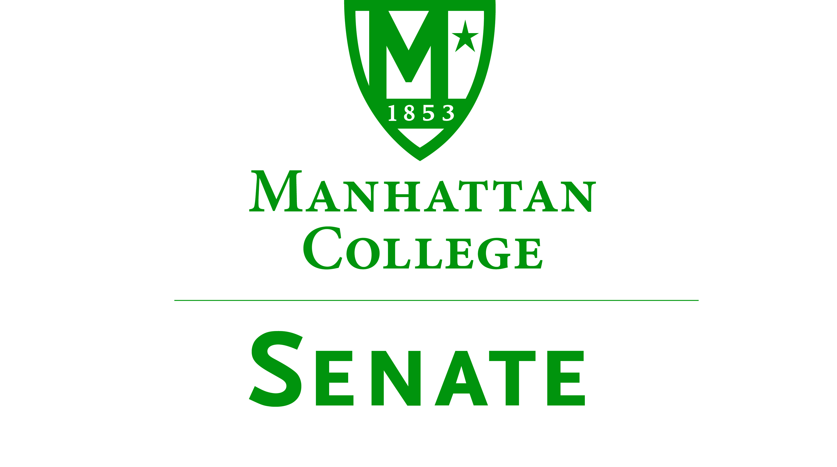
Wednesday, May 2nd 2018 | 12:00pm | Miguel 311 (Rodriguez Room)
Special Elections Meeting
Draft Minutes
- Meeting called to order by Speaker Jayawickreme at 12:08PM.
- Roll Call Quorum Met)
  - Senators Present: Richard Saterlee, Sonny Ago, Tim Ward, Keith Brower, William Clyde, Michael McEneney, Dominika Wrozynski, Nuwan Jayawickreme, Amira Annabi, Shawna BuShell, William Merriman, Jessica Wilson, Daniel Hochstein, Amy Handfield, Ankur Agrawal, Carolann O'Connor, Isabel Quinones, Timothy Gress, Danielle Young, Fengyun Wu, Liam Moran, Michael Hackett, Quinn Caffrey, Giuliana DeLuca, Mehdi Omidvar, Gerardo Carfagno,
  - Senators Not Present: Crystal Xu, Lawrence Udeigwe, Margaret McKiernan, Kaitlyn Von Runnen, Joseph Moussa, Lisamarie Nilaj, Chris Cacciavillani, Jenna Zawislak, Ryan Quattromani (excused), Michael Szczech, (excused) Julius Benecz
- Approval of the Agenda
  - Motion Passed
- Approval of Previous Minutes
  - Motion Passed with Corrections
- Reading from the Green Book (pg. #42)
- Elections
  - Speaker- Liam Moran: Self Nominated, Unopposed, Elected
  - First Deputy Speaker- Tim Ward: Self Nominated, Unopposed, Elected
  - Second Deputy Speaker- Fengyun Wu: Self Nominated, Unopposed, Elected
  - Secretary- Timothy Gress: Self Nominated, Unopposed, Elected
- Old Business
  - None
- New Business
  - Senator Tim Ward reminds senate that the Minimum Wage is increasing to $15.00 per hour January 2019. Consideration must be made regarding budgets.
  - Senator Satterlee suggests the newly elected President consider offering Roberts Rules of Order workshops for Senate members. Newly elected President Moran has considered this workshop idea and plans to implement in the coming year. Will report back to the Senate on the plans progress.
  - Senator Tim Ward proposes the consideration of a smaller number of Senators appointed in the future.
- Good of the Order
  - Thank you to outgoing officers for their commitment to their positions
- Adjourn 12:35 pm

