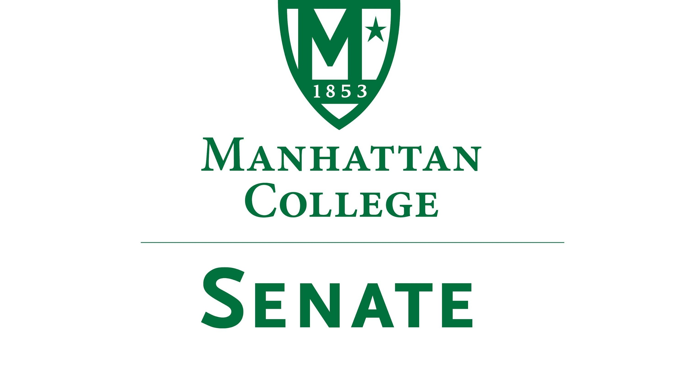
Tuesday, September 18th 2017 | 3:35pm | Kelly Commons Room 5A
Draft
Minutes
- Roll Call: Quorum Met
- Senators Present: Richard Satterlee, Sonny Ago, Keith Brower, Tim Ward, William Clyde, Michael McEneney, Fengyun Wu, Shawna BuShell, William Merriman, Daniel Hochstein, Mehdi Omidvar, Danielle Young, Dominika Wrozynski, Gerardo Carfagno, Lawrence Udeigwe, Peggy McKiernan, Isabel Quinones, Quinn Caffrey, Timothy Gress, Giuliana DeLuca, Liam Moran, Julius Benecz
- Senators Not Present: Amira Annabi (excused), Mehdi Omidvar (excused), Amy Handfield, Carol Ann O’Connor, Kaitlyn Von Runnen, Michael Hackett (excused), Ryan Quattromani (excused)
- Approval of the Agenda
- Passed
- Approval of Previous Minutes
- Passed
- Reading from the Green Book. St. John Baptiste De LaSalle
- State of the College Update, President Brennan O’Donnell
  - Dr. O’Donnell brings attention to three reports: President’s Report, Career Outcomes Report, and Focus on Faculty.
  - Reminds the Senate of the summer construction mainly relating to the construction of the new Engineering and Science building and the new athletic complex on the previous site of the Physical Plant offices.
  - Strong fiscal year with 97 million dollars in new commitments to the College to go along with another year of strong enrollment. However, Dr. O’Donnell acknowledges that there are still some issues in retaining students and keeping the residence halls at full capacity. There are plans to renovate the residence halls in the near future. Plans for the building of a future residence building are on hold.
  - Looking for an increase in international students and a more diverse group of students in general next year.
- Speaker’s Report
- Speaker Liam Moran introduces himself and notes that he is looking forward to working closely with the senators and their constituencies this year.
- Speaker Moran hopes to make the efforts of the Senate more visible and accessible to the wider College population.
- Reports from the Standing Committees
  - Educational Affairs Commission (EAC)
    - Presentation by Senator Clyde
      - Further discussion of the Academic Policy and Integrity Language which was carried over from the previous academic year. A new committee has been formed.
      - Senator Ward brings up the point that there is no dean on the committee.
  - Senator Clyde replies that the work of this committee will be passed around via the dean’s council before it is officially approved.
  - Campus Life Committee
    - Presentation by Senator Ago
      - Committee did not meet. Still looking for student and Senate volunteers for the committee.
      - Senator Ago went through a brief list of updates for the office of Student Life which included searches for a new head of the fitness center and head of Residence Life.
      - Senator Ago also went on to state that the Campus Life Committee has worked on improving the commuter student experience and works closely with Residence Life and Public Safety.
- Senate Proposal 1 – 2018-2019: “New Arrangement to Resolve Employee Parking Crisis Created by Elimination of Leo Parking Lot.”
  - Presentation by Senator Udeigwe on behalf of Ira Gerhardt.
      - There was then an additional presentation by Senator Satterlee before the proposal was brought to a vote.
        - Senator Satterlee is working with Public Safety to address the acknowledged problem of a finite number of parking spots on campus as a result of the loss of the Leo parking lot.
        - Reports that, during the busiest times of the day, there are still about 22-30 sports available for use in the garage. Public Safety is looking into the possibility of technology that can allow someone to find where these empty spots are to limit time spent searching for parking.
        - The gate on Broadway is now open to allow easier access for students and faculty coming from south campus. This entrance will be closed once a blue light and a new card reader system are installed to allow for access into the garage from Broadway.
      - Senator Udeigwe asked the question of why the original plans for a parking lot were now taken out of the construction plans.
        - Senator Ward notes that these decisions were made by a steering committee and were made not only to save up to 10 million dollars, but also because of structural and electrical concerns.
        - Senator Clyde notes that the decision was made with the understanding that there would still be enough parking in the garage.
  - Debate is closed and the proposal to turn the 240th street lot from student use into faculty only parking is voted on.
    - The proposal is voted down and the motion is not agreed to.
      - Dean Ward requested that the minutes reflect that this is a serious issue and will continue to be evaluated in an effective way by the department of Student Life. It effects a growing number of commuter students on campus.
- Old Business
- None
- New Business
- Topics from the Agenda Committee
    - Minimum Wage ($ 13 per hour to $ 15 per hour transition)
    - Review of Senate By-laws
    - Advertise the Senate Activities to all constituencies
      - Senator Clyde suggests that the editor of the Quadrangle receive the agenda in advance and that someone from the newspaper attend senate meetings.
      - Senator BuShell notes that the Senate does have social media accounts and that they be used more effectively.
    - Potential March Meeting – March 12, 2019
- Topics from Senate Membership
    - Senator McEneney requests that page 136 of the College handbook be changed to reflect the new number of Alumni representatives. The number had been changed from 2 to 1 a number of years ago and this change was not documented in the handbook.
    - Senator Quinones commented that students in the education department are overloaded by field work and that their class schedules make it difficult to find enough hours to meet the requirements.
      - Speaker Moran adds that this is not a Senate wide issue and should be brought to the attention to the Dean of the respective school.
- Adjourn at 4:53 pm

