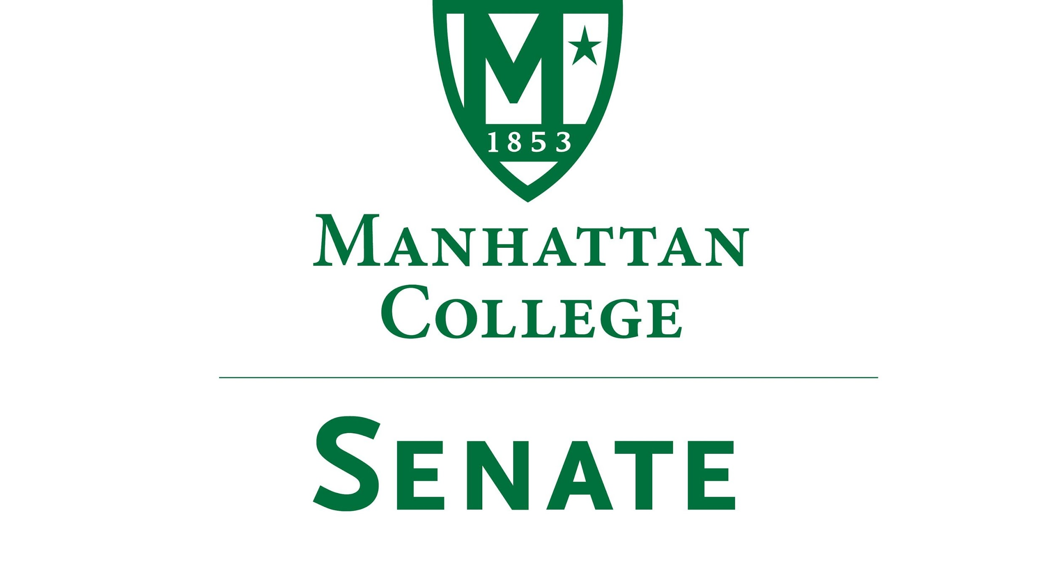
Tuesday, November 20th 2018 | 3:35pm | Alumni Room
Draft
Minutes
- Roll Call: Quorum Met
- Senators Present: Richard Satterlee, Sonny Ago, Keith Brower, Tim Ward, Michael McEneney, William Clyde, Amira Annabi, Fengyun Wu, William Merriman, Daniel Hochstein, Mehdi Omidvar, Danielle Young, Amy Handfield, Gerardo Carfagno, Quinn Caffrey, Timothy Gress, Giuliana DeLuca, Liam Moran, Julius Benecz, Kaitlyn Von Runnen, Michael Hackett, Peggy McKiernan
- Senators Not Present: Carol Ann O’Connor (excused), Lawrence Udeigwe, Ryan Quattromani, Shawna BuShell (excused), Dominika Wrozynski (excused), Isabel Quinones (excused)
- Approval of the Agenda
- Passed
- Approval of Previous Minutes
- Passed
- Reading from the Green Book. St. John Baptiste de La Salle, page 17.
- Speaker’s Report
- Speaker Liam Moran reports that there have been no anonymous complaints filed through the Senate Moodle page.
- Speaker Moran reports that the Senate agenda committee is currently working to review Senate bylaws and welcomes guests to this Senate meeting.
- Reports from the Standing Committees
  - Educational Affairs Commission (EAC)
    - Presentation by Senator Clyde
      - Senator Clyde reports that the revised grade replacement policy has been passed by the EAC. This new policy allows for students who earned a C or lower to retake the course. If a lower grade is received the student should not apply for the grade change.
        - After these facts were presented there was a brief discussion regarding the specifics of the policy. Senator Wu inquired specifically about the implementation of the policy in the school of business.
          - Senator Clyde responded by noting that particular aspects of the newly proposed grade replacement policy were already implemented in the prior policy approved in 2014. Senator Ward reminds the Senate that courses should be repeated within a year of the initial enrollment with the approval of the dean of the respective school. Senator Ward also noted that there is still an application process. After this Senator Young noted that the Liberal Arts chairs would be presenting at the next EAC meeting.
        - This policy is to be effective immediately.

      - Senator Clyde shares an update on the revisions of the academic integrity policy. It may be finalized at the December EAC meeting and is now structured in a way that presents clearer language and that is fair to students.
      - Senator Clyde announces that the new Academic calendar for the new several years has been released.
      - Senator Clyde announces that there is discussion regarding the change of independent study implementation.
  - Campus Life Committee
    - Presentation by Senator Ago
      - The Campus Life Committee reports of its first and only meeting of the Fall semester.
      - Senator Ago reports that, beginning with the Fall 2019 semester, there will be a two-year residency requirement before a student can move off campus. Those living with their parent/guardian at a verifiable address, student veterans, and those over the age of 23 are not affected by this policy.
        - This policy is trying to address the current occupancy downturn (a decline of approximately 200 occupants) through new policy and upgrading current housing stock.
      - Senator Ago reports on the ongoing efforts to enhance the living and learning communities. This is a conversation with an outside consultant to upgrade the dorms and develop the community. This will take place within two years.
      - Senator Ago reports on the flyer posting policy.
        - The current policy is being violated and thus is being reviewed by students and administrators from various offices around campus.
          - One of the major concerns noted from this group was the damage to the paint on the walls in the Kelly Commons and Thomas Hall.
  - Commencement 2019 Forum
    - Conversation about the location and number of tickets for the upcoming 2019 Commencement experiences. Senate guests have been invited to voice their concerns.
      - Guest Kerry Cavanaugh asks how large events at Gaelic Park are coordinated.
      - Senator Clyde encourages those in attendance to refer to the email he sent out to the College community regarding an update on Commencement.
      - Senator Clyde reports that he is working with the registrars’ office in order to grasp an accurate number of people who are registered and who will be attending graduation. If this takes place it will be possible for each graduating senior to receive up to three tickets.
      - Senator Clyde notes that the College is working with an architect to increase the number of doors in Draddy gymnasium, thus increasing legal capacity. This plan is waiting to be approved. If this plan is approved there will be four tickets per person. There will be an announcement before the Christmas break. The goal is to get the gym to be able to hold above 4,500 people.
      - Kerry Cavanaugh asks Senator Clyde to provide an update about a survey regarding 2020 Commencement.
        - Senator Clyde reports that the survey would be sent out to student government in the spring for the Junior class of 2020. The parents of the class of 2020 will also receive this survey.
      - Senator Clyde goes into further detail about some of the other venues that were not chosen for the event such as the Javits Center, Madison Square Garden, and Radio City Music Hall.
        - There is a push by the College to expand the capacity of Gaelic Park with the intention of Draddy gym as a rain location. However, the MTA, who owns the park, must approve the seating plan.
      - Senator Von Runnen thanks Senator Clyde for the update and email that was sent out to the College community. She remarks that the events surround commencement reveal a need for the College to be more transparent when it comes to relaying information with the student body.
        - Senator Clyde responds by noting that it the notice regarding the distribution of two tickets was a mistake and should not have been sent out.
      - Senator Satterlee, responding to this statement, suggests that next year’s student government officers meet with the senior administration of the College in order to discuss the roles that people on campus play in an effort to better facilitate dialogue between the two groups.
      - There is a short recess of approximately 10 minutes.
      - Senator Ward introduces a proposal regarding Commencement.
        - The proposal reads: “The Senate requests that upper administration continue to pursue viable alternate options for commencement venues now and into the future.
          - The motion is agreed upon.
- New Business
  - Topics from the Agenda Committee
    - Mention of the possible formation of an ad-hoc committee set up to discuss the review of the Senate bylaws.
  - Topics from the Senate Membership
Senator Satterlee asks to have the matter of non-members of the Senate wanting to speak in debates and conversations be reviewed and subsequently addressed.
- Adjourn at 4:40 pm

